Strawberry DNA Testing Handbook

May 2019

RosBREED

**Contributing Authors**

**Nahla V. Bassil**, USDA-ARS National Clonal Germplasm Repository

**Seonghee Lee**, Department of Horticultural Science, IFAS Gulf coast research and Education Center, University of Florida

**Youngjae Oh**, Department of Horticultural Science, IFAS Gulf coast research and Education Center, University of Florida

**Jason D. Zurn**, USDA-ARS National Clonal Germplasm Repository

**Table of Contents**

**Introduction** 1

**Flowering Traits** 2

***FaPFRU* (Bx215)** 2

***FaPFRU* (UFDNHRM01)** 5

**Fruit Traits** 8

***FaFAD1* (qFaFAD1)** 8

***FaFAD1* (UFGDHRM5)** 11

***FaFAD1* (UFGDHRM01)** 14

***FaOMT* (FaOMTSI/NO)** 17

**Disease Resistance** 19

***FaRPc2* - H2 *(*UFPc2HRM01)** 19

***FaRPc2* - H2 (UFPc2HRM03)** 23

***FaRPc2 -* H3 (UFPc2HRM02)** 26

***FaRPc2 -* H3 (UFPc2HRM04)** 30

***FaRPc2* - H3 (RPCKASPH3)** 33

***FaRXf1* (HRM6D_33.083)** 36

***FaRXf1* (UFXf1HRM01)** 39

***FaRXf1* (UFXf1HRM02)** 42

***FaRCa1*** **(UFCa1HRM01)** 45

***FaRCg1* (UFCg1HRM01)** 48

**Multiplex Protocols** 51

***FaFAD1* (qFaFAD1) + *FaOMT* (FaOMTSI/NO)** 51

***FaRPc2* (UFPc2HRM01) + *FaRCa*1 (UFCa1HRM02)** 54

***FaRPc2* (UFPc2HRM02) + *FaRCa1* (UFCa1HRM02)** 58

***FaFAD1* (UFGDHRM5) + *FaRPc2* (RPCHRM3)** 62

**References** 66

# **Introduction**

The RosBREED project is a USDA-NIFA specialty crops research initiative project focused on leveraging genetic information to improve rosaceous crops. The RosBREED project focuses on eight crops: apple, blackberry, peach, pear, rose, strawberry, sweet cherry, and tart cherry. The first RosBREED grant (2009-51181-05808) was funded in 2009 and developed many populations, phenotyping protocols, phenotypic and genotypic data, genomic resources, and tools to analyze them. The first grant was focused on identifying QTLs for fruit quality traits. The second RosBREED grant (2014-51181-22378) built upon the initial work done by combining those QTLs for horticultural quality with disease resistance loci identified during this second grant in DNA tests that can be used in DNA-informed breeding.

Research in strawberry in the RosBREED project led to numerous tests. To assist breeders and companies/laboratories providing diagnostic testing to breeders, we have compiled a compendium of DNA tests for strawberries. The purpose of this compendium is to distil information from primary literature related to the DNA tests, help identify primary literature associated with these tests, provide a starting point for test optimization, and assist in the interpretation of tests for informed breeding decisions.

In this book, tests are organized by trait (e.g. fruit quality and disease resistance), the gene/QTL being tested, and the test being used. Multiple tests exist for some genes/QTLs that differ in how they are interpreted (e.g. a test visualized via capillary electrophoresis versus one visualized via melt curve analysis). Each test will be listed to allow users to best adapt to available laboratory equipment. For each test, a brief background is provided telling the user: 1) what trait the test targets, 2) what gene/QTL is targeted, and 3) what resources are available that can further describe the test. Next the technical details of the test are provided including the primer sequences and suggested starting reaction mixtures and PCR protocols. Following the technical details, a description of how to interpret the test and control cultivars are listed. Many of these control cultivars can be found at the USDA-ARS National Clonal Germplasm Repository in Corvallis, OR. The final section consists of additional notes and caveats surrounding the test. Users are reminded to read the entire protocol prior to use to identify any caveats related to their testing needs.

# **Flowering Traits**

### FaPFRU (Bx215)

**Background**

* A test for perpetual flowering.
* Targets *FaPFRU* QTL on chromosome 4-3 associated with the perpetual flowing source discovered by Bringhurst in the Wasach mountains in Utah (Bringhurst and Voth, 1980).
* The marker was designed by Perrotte et al. (2016) and validated by Salinas et al. (2017). Allele names reported are the observed fragment sizes from Salinas et al. (2017).

**Technical Details**

***Primer Sequences***

|  |  |
| --- | --- |
| **Primer** | **Sequence** |
| Bx215-F | CAATTTCCCGCCAAAAGTAA |
| Bx215-R | GTTTGTTGGAGCTTCGAGCAAGTT |

Physical locations of primers in octoploid reference genome (cv. Camarosa)

Bx215-F: 2,837,482 bp

Bx215-R: -

***Primer Master Mix***

|  |  |  |
| --- | --- | --- |
| **Component** | **Concentration** | **Amount (μL)** |
| Bx215-F | 10 μM | 0.5 |
| Bx215-R | 10 μM | 0.5 |
| ddH2O |  | 11 |
| **Total** |  | 12 |

***Reaction Master Mix***

|  |  |  |
| --- | --- | --- |
| **Component** | **Concentration** | **Amount for 1 reaction (μL)** |
| TypeIT master mixa | 2X | 8.3 |
| Primer Master Mix | 0.83 μM | 1.7 |
| Q solution |  | 1.7 |
| DNA | 3 ng/μL | 3.3 |
| **Total** |  | 15 |

aQiagen (catalog number: 206241, 206243, or 206246)

***PCR Program***

|  |  |  |
| --- | --- | --- |
| **Temperature (°C)** | **Time (mm:ss)** | **Cycles** |
| 95 | 5:00 |  |
| 95 | 0:30 |  |
| 65 - 1°C/cycle | 1:30 | 10 |
| 72 | 0:30 |  |
| 95 | 0:30 |  |
| 55 | 1:30 | 30 |
| 72 | 0:30 |  |
| 60 | 30:00 |  |
| 4 | hold |  |

The test is visualized via capillary electrophoresis or via 6% poly-acrylamide gel electrophoresis.

**Interpretation**

|  |  |  |
| --- | --- | --- |
| **Predicted Trait** | **Alleles** | **Examples** |
| *Perpetual Flowering* | 128 bp allele present | Albion, Aromas, Hecker, Mara des Bois, Seascape, Selva, Tribute |
| *Seasonal Flowering* | 128 bp allele absent | Camarosa, Charm, Honeoye, Jewel, Puget Crimson, Strawberry Festival |



**Bx215 Figure 1.** Electropherogram showing an example of a seasonal flowering and perpetual flowering result.

**Additional Notes**

The Bx215 test is not predictive in the seasonal flowering strawberries ‘Earliglow’, ‘Elsanta’, and ‘Sweet bliss’ as all have the 128 bp allele predictive of perpetual flowering (Perrotte et al., 2016; Salinas et al., 2017). As such, this test may not be predictive for perpetual flowering for cultivars with these cultivars in there pedigree.

### FaPFRU (UFDNHRM01) – Unpublished marker

**Background**

* A test for perpetual flowering.
* Targets *FaPFRU* QTL on chromosome 4-3 associated with the perpetual flowing source discovered by Bringhurst in the Wasach mountains in Utah (Bringhurst and Voth, 1980).
* Targets *FaPFRU* QTL on chromosome 4-3 associated with the perpetual flowing.

**Technical Details**

***Primer Sequences***

|  |  |
| --- | --- |
| **Primer** | **Sequence** |
| UFDNHRM01-F | Not available yet (Unpublished data) |
| UFDNHRM01-R |

Physical locations of primers in octoploid reference genome (cv. Camarosa)

UFDNHRM01-F: not available yet

UFDNHRM01-R: not available yet

***Reaction Master Mix***

|  |  |  |
| --- | --- | --- |
| **Component** | **Concentration** | **Amount for 1 reaction (μL)** |
| AccuStartTM II PCR ToughMix®a | 2X | 2.5 |
| UFDNHRM01-F | 5 μM | 0.75 |
| UFDNHRM01-R | 5 μM | 0.75 |
| LCGreen® Plusb |  | 0.25 |
| Sterile PCR water |  | 0.75 |
| DNA | 50 ng/μL | 0.5 |
| **Total** |  | 5.5 |

aQuantabio (catalog number: 95142-100, 95142-800, or 95142-04K)

bBioFire Defense (catalog number: BCHM-ASY-0005 or BCHM-ASY-0006)

***PCR Program***

|  |  |  |  |
| --- | --- | --- | --- |
| **Temperature (°C)** | **Time (mm:ss)** | **Cycles** | **Process** |
| 95 | 3:00 |  |  |
| 95 | 0:10 |  | PCR |
| **60** | 0:10 | 45 |  |
| 72 | 0:10 |  |  |
| 95 | 1:00 |  | HRM |
| 50 | 1:00 |  |  |
| 94 | Continuous |  |  |
| 40 | 0:30 |  |  |
| 4 | Hold |  |  |

The PCR and HRM analysis were performed in a LightCycler® 480 (Roche Life Science).

**Interpretation**

|  |  |  |
| --- | --- | --- |
| **Predicted Trait** | **Alleles** | **Examples** |
| *Perpetual Flowering* | Perpetual Flowering Cluster (PF) | Florida Beauty, Mara des Bois, Monterey, Portola |
| *Seasonal Flowering* | SeasonalFlowering  Cluster (SF) | Camarosa, Florida Brilliance, Florida Elyana, Strawberry Festival, Sweet Charlie, Sweet Sensation® ‘Florida 127’ |

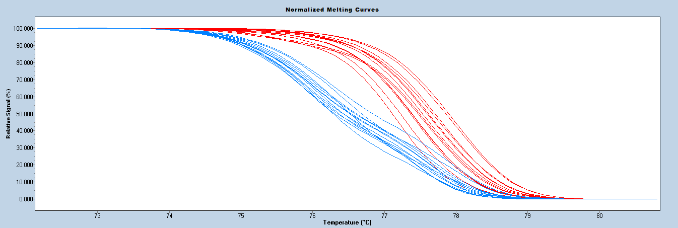

PF

SF

A

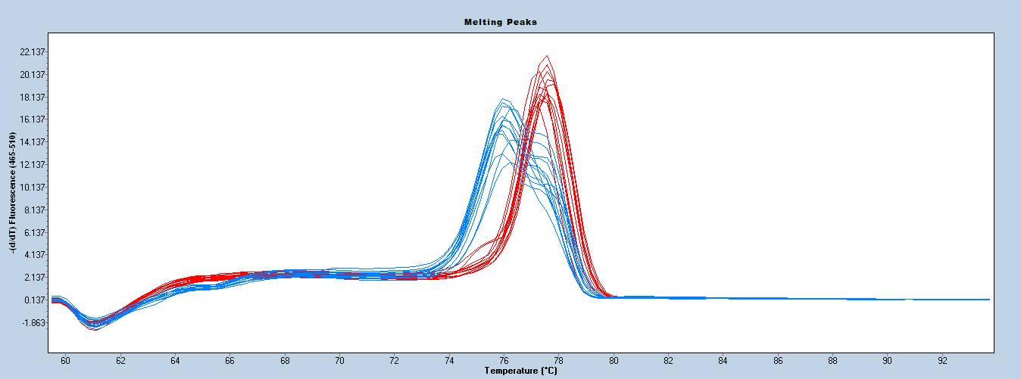

B

PF

SF

**UFDNHRM01 Figure 1.** Melting curve patterns derived by the HRM analysis using UFDNHRM01. In normalized melting curves **(A)** and melting curves **(B)** analysis, perpetual flowering (PF) accessions shown blue curve pattern and seasonal flowering (SF) accessions shown red curve pattern.

**Additional Notes**

The UFDNHRM01 test is not predictive in the seasonal flowering strawberry ‘Earliglow’. As such, this test may not be predictive for perpetual flowering for cultivars with these cultivars in their pedigree. Control samples should always be used with HRM analysis to identify the melt clusters. This marker works well with crude DNA prepared by NaOH based rapid extraction.

# **Fruit Traits**

### FaFAD1 (qFaFAD1)

**Background**

* A conventional gel-based marker test for γ-decalactone content in fruit.
* Targets *FaFAD1* on chromosome 3-2 associated with a severe reduction/absence of γ-decalactone.
* The marker was designed by Sánchez-Sevilla et al. (2014) and is a perfect dominant marker.

**Technical Details**

***Primer Sequences***

|  |  |
| --- | --- |
| **Primer** | **Sequence** |
| qFaFAD1-F | TCTGTACTCTACCGCCTTGC |
| qFaFAD1-R | TCGTAGTGTGGCAGTGAAGG |

Physical locations of primers in octoploid reference genome (cv. Camarosa)

qFaFAD1-F: sequence is not present in Camarosa reference genome.

qFaFAD1-R: sequence is not present in Camarosa reference genome.

***Reaction Master Mix***

|  |  |  |
| --- | --- | --- |
| **Componenta** | **Concentration** | **Amount for 1 reaction (μL)** |
| PCR Buffer | 5X | 3 |
| MgCl2 | 25 mM | 1.2 |
| dNTP’s | 2.5 mM | 1.2 |
| qFaFAD1-F | 10 μM | 0.15 |
| qFaFAD1-R | 10 μM | 0.15 |
| Taq |  | 0.2 |
| ddH2O |  | 6.1 |
| DNA | 3 ng/μL | 3 |
| **Total** |  | 15 |

aPromega (catalog number: M5001, M5005, M5006, or M5008)

***PCR Program***

|  |  |  |
| --- | --- | --- |
| **Temperature (°C)** | **Time (mm:ss)** | **Cycles** |
| 95 | 3:00 |  |
| 95 | 0:30 |  |
| 55 | 0:30 | 35 |
| 72 | 0:45 |  |
| 60 | 7:00 |  |
| 4 | hold |  |

The test is visualized via 2% agarose unless performed in multiplex with FaOMTSI/NO *FaOMT* test. Alternatively the test can be run with a real-time thermocycler.

**Interpretation**

|  |  |  |
| --- | --- | --- |
| **Predicted Trait** | **Alleles** | **Examples** |
| *γ-decalactone Produced* | 140 bp allele present | Florida Radiance, Sweet Sensation® ‘Florida 127’, Winterstar |
| *γ-decalactone Not Produced* | 140 bp allele absent | Camarosa, Mara des Bois, Winter Dawn |



**qFaFAD1 Figure 1.** Example of a positive and negative interpretation of qFaFAD1.

**Additional Notes**

The qFaFAD1 test is a perfect dominant marker. As such, heterozygote cannot be identified using the current test. The qFaFAD1 test can be multiplexed with the FaOMTSI/NO primer set for mesifurane (Cruz-Rus et al., 2017). When multiplexing the test should be visualized on a 3% agarose gel.

### FaFAD1 (UFGDHRM5)

**Background**

* A high-throughput DNA test for γ-decalactone content in fruit.
* Targets *FaFAD1* on chromosome 3-2 associated with a severe reduction/absence of γ-decalactone.
* The marker was designed by Noh et al., (2017) and has been shown to be predictive in germplasm originating from University of Florida breeding program.

**Technical Details**

***Primer Sequences***

|  |  |
| --- | --- |
| **Primer** | **Sequence** |
| UFGDHRM5-F | CCTCGATCATAGCTACACTCTTTC |
| UFGDHRM5-R | AGCCTTTGACGTGTCCTTATT |

Physical locations of primers in octoploid reference genome (cv. Camarosa)

UFGDHRM5-F: Sequence is not present in Camarosa reference genome.

UFGDHRM5-R: Sequence is not present in Camarosa reference genome.

***Reaction Master Mix***

|  |  |  |
| --- | --- | --- |
| **Component** | **Concentration** | **Amount for 1 reaction (μL)** |
| AccuStartTM II PCR ToughMix®a | 2X | 2.5 |
| Primer Mix (F+R) | 5 μM | 1.5 |
| LCGreen® Plusb |  | 0.25 |
| Sterile PCR water |  | 0.75 |
| DNA | 50 ng/μL | 0.5 |
| **Total** |  | 5.5 |

aQuantabio (catalog number: 95142-100, 95142-800, or 95142-04K)

bBioFire Defense (catalog number: BCHM-ASY-0005 or BCHM-ASY-0006)

***PCR Program***

|  |  |  |  |
| --- | --- | --- | --- |
| **Temperature (°C)** | **Time (mm:ss)** | **Cycles** | **Process** |
| 95 | 3:00 |  |  |
| 95 | 0:10 |  | PCR |
| 62 | 0:10 | 35 |  |
| 72 | 0:10 |  |  |
| 95 | 1:00 |  | HRM |
| 55 | 1:00 |  |  |
| 95 | Continuous |  |  |
| 40 | 0:30 |  |  |
| 4 | Hold |  |  |

The PCR and HRM analysis were performed in a LightCycler® 480 (Roche Life Science).

**Interpretation**

|  |  |  |
| --- | --- | --- |
| **Predicted Trait** | **Alleles** | **Examples** |
| *γ-decalactone Produced* | γ-decalactone producing cluster  (GD) | Florida Brilliance,Florida Radiance,  Sweet Sensation® ‘Florida 127’,  Sweet Charlie, Winterstar |
| *γ-decalactone Not Produced* | non-amplification  (Non-GD) | Camarosa, Mara des Bois, Monterey,  Treasure, Winter Dawn |

**UFGDHRM5 Figure 1.** Melting curve patterns derived by the HRM analysis using UFGDHRM5. In melting curves analysis, γ-decalactone producing and non-producing accessions shown blue and red curve pattern, respectively.

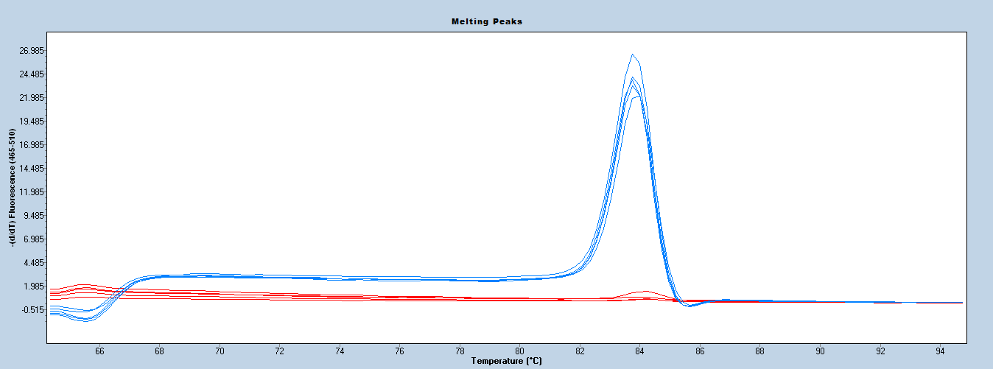

Producer

Non-producer

**Additional Notes**

The UFGDHRM5 is a dominant marker. As such, heterozygote cannot be identified using the current test (Noh et al., 2017). The UFGDHRM5 can be multiplexed with the RPCHRM3 primer set for *Phytophthora cactorum* resistance (*FaRPc2* H3 haplotype). Control samples should always be used with HRM analysis to identify the melt clusters. This marker works well with crude DNA prepared by NaOH based rapid extraction.

### FaFAD1 (UFGDHRM01) – Unpublished marker

**Background**

* A high-throughput DNA test for γ-decalactone content in fruit.
* Targets *FaFAD1* on chromosome 3-2 associated with a severe reduction/absence of γ-decalactone.
* This HRM marker was designed by Oh et al., (201x) and has been shown to be predictive in germplasm originating from University of Florida breeding program.

**Technical Details**

***Primer Sequences***

|  |  |
| --- | --- |
| **Primer** | **Sequence** |
| UFGDHRM01-F | Not available yet (unpublished data) |
| UFGDHRM01-R |

Physical locations of primers in octoploid reference genome (cv. Camarosa)

UFGDHRM01-F: Not available yet

UFGDHRM01-R: Not available yet

***Reaction Master Mix***

|  |  |  |
| --- | --- | --- |
| **Component** | **Concentration** | **Amount for 1 reaction (μL)** |
| AccuStartTM II PCR ToughMix®a | 2X | 2.5 |
| Primer Mix (F+R) | 5 μM | 1.5 |
| LCGreen® Plusb |  | 0.25 |
| Sterile PCR water |  | 0.75 |
| DNA | 50 ng/μL | 0.5 |
| **Total** |  | 5.5 |

aQuantabio (catalog number: 95142-100, 95142-800, or 95142-04K)

bBioFire Defense (catalog number: BCHM-ASY-0005 or BCHM-ASY-0006)

***PCR Program***

|  |  |  |  |
| --- | --- | --- | --- |
| **Temperature (°C)** | **Time (mm:ss)** | **Cycles** | **Process** |
| 95 | 3:00 |  |  |
| 95 | 0:10 |  | PCR |
| **62** | 0:10 | 35 |  |
| 72 | 0:10 |  |  |
| 95 | 1:00 |  | HRM |
| 55 | 1:00 |  |  |
| 95 | Continuous |  |  |
| 40 | 0:30 |  |  |
| 4 | Hold |  |  |

The PCR and HRM analysis were performed in a LightCycler® 480 (Roche Life Science).

**Interpretation**

|  |  |  |
| --- | --- | --- |
| **Predicted Trait** | **Alleles** | **Examples** |
| *γ-decalactone Produced* | γ-decalactone producing cluster (GD) | Florida Brilliance, Florida Radiance,  Sweet Sensation® ‘Florida 127’,  Sweet Charlie, Winterstar |
| *γ-decalactone Not Produced* | non-amplification  (Non-GD) | Camarosa, Mara des Bois, Monterey, Treasure, Winter Dawn |

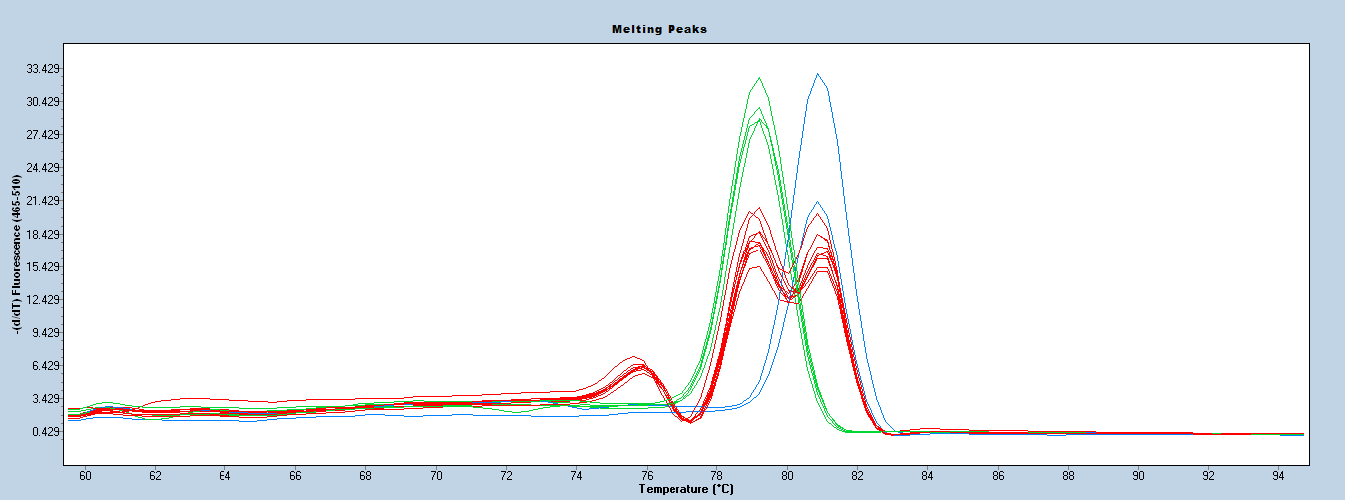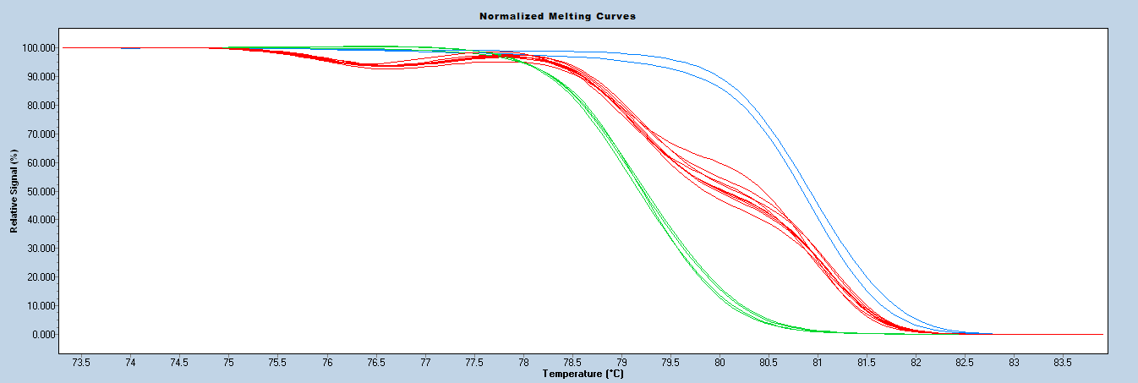

GD Nonproducer

GD Producer (Hetero)

GD Producer (Homo)

GD Nonproducer

GD Producer (Hetero)

GD Producer (Homo)

**A**

**B**

**UFGDHRM01 Figure 1.** Melting curve patterns derived by the HRM analysis using UFGDHRM01. In the normalized melting curves (A) and melting curves (B) analysis, γ-decalactone producing homozygous and heterozygous accessions are shown in blue and red curve pattern, respectively, and non-producing accessions shown red curve pattern.

**Additional Notes**

The codominant γ-decalactone marker, UFGDHRM01, can be effectively detect the γ-decalactone producing accessions containing the homozygote and heterozygote genotype. Control samples should always be used with HRM analysis to identify the melt clusters. This marker works well with crude DNA prepared by NaOH based rapid extraction.

### FaOMT (FaOMTSI/NO)

**Background**

* A test for mesifurane content in fruit.
* Targets *FaOMT* on chromosome 7b associated with a severe reduction in mesifurane content.
* The marker was designed by Zorrilla-Fontanesi et al. (2012) and is a perfect marker.

**Technical Details**

***Primer Sequences***

|  |  |
| --- | --- |
| **Primer** | **Sequence** |
| FaOMTSI/NO-F | CGATCATTTCGAAAAGGACTAGT |
| FaOMTSI/NO-R | AAGCAGGGTTAGTTGTGGAGA |

***Reaction Master Mix***

|  |  |  |
| --- | --- | --- |
| **Componenta** | **Concentration** | **Amount for 1 reaction (μL)** |
| PCR Buffer | 5X | 3 |
| MgCl2 | 25 mM | 1.2 |
| dNTP’s | 2.5 mM | 1.2 |
| FaOMTSI/NO-F | 10 μM | 0.15 |
| FaOMTSI/NO-R | 10 μM | 0.15 |
| Taq |  | 0.2 |
| ddH2O |  | 6.1 |
| DNA | 3 ng/μL | 3 |
| **Total** |  | 15 |

aPromega (catalog number: M5001, M5005, M5006, or M5008)

***PCR Program***

|  |  |  |
| --- | --- | --- |
| **Temperature (°C)** | **Time (mm:ss)** | **Cycles** |
| 95 | 3:00 |  |
| 95 | 0:30 |  |
| 55 | 0:30 | 35 |
| 72 | 0:45 |  |
| 60 | 7:00 |  |
| 4 | hold |  |

The test is visualized via 3% agarose gel.

**Interpretation**

|  |  |  |
| --- | --- | --- |
| **Predicted Trait** | **Alleles** | **Examples** |
| *Mesifurane Produced* | 248/248 bp | Mara des Bois, Monterrey |
| *Mesifurane Produced* | 217/248 bp | Camarosa, Strawberry Festival, Sweet Charlie, Winterstar |
| *Mesifurane Not Produced* | 217/217 bp | Deutsch Evern, Hood |



**FaOMTSI/NO Figure 1.** Examples of homozygous and heterozygous allele calls for the FaOMTSI/NO test.

**Additional Notes**

The FaOMTSI/NO test is a perfect marker and the 217 bp allele indicates a loss of mesifurane production when in a homozygous state. Other genes within the pathway can also cause a loss of mesifurane production and many cultivars have been identified that do not produce mesifurane despite having a heterozygous or 248 bp homozygous genotype (Cruz-Rus et al., 2017). The FaOMTSI/NO test can be multiplexed with the qFaFAD1 primer set for γ-decalactone (Cruz-Rus et al., 2017).

# **Disease Resistance**

### FaRPc2 - H2 (UFPc2H2HRM01)

**Background**

* A test for *Phytophthora cactorum* crown rot resistance.
* Targets only one of two haplotypes (the *FaRPc2* H2haplotype on chromosome 7-3) associated with resistance.
* The marker has been shown to be predictive in germplasm originating from the University of Florida breeding program.

**Technical Details**

***Primer Sequences***

|  |  |
| --- | --- |
| **Primer** | **Sequence** |
| UFPc2H2HRM01-F | AAAGTGGATGGTAAGAAATGAGC |
| UFPc2H2HRM01-R | CTCCAGATCTACTGTTATGTCCTC |
| UFPc2H2HRM01-F-probe | TCGAGGAAGACATGAAGGACGAGA |

Physical locations of primers in octoploid reference genome (cv. Camarosa)

UFPc2HRM01-F: 2,188,024 bp

UFPc2HRM01-R: 2,188,123 bp

***Reaction Master Mix***

|  |  |  |
| --- | --- | --- |
| **Component** | **Concentration** | **Amount for 1 reaction (μL)** |
| AccuStartTM II PCR ToughMix®a | 2X | 2.5 |
| UFPc2H2HRM01-F | 5 μM | 0.1 |
| UFPc2H2HRM01-R | 5 μM | 0.5 |
| UFPc2H2HRM01-F-probe | 5 μM | 0.5 |
| LCGreen® Plusb |  | 0.25 |
| Sterile PCR water |  | 1.15 |
| DNA | 50 ng/μL | 0.5 |
| **Total** |  | 5.5 |

aQuantabio (catalog number: 95142-100, 95142-800, or 95142-04K)

bBioFire Defense (catalog number: BCHM-ASY-0005 or BCHM-ASY-0006)

***PCR Program***

|  |  |  |  |
| --- | --- | --- | --- |
| **Temperature (°C)** | **Time (mm:ss)** | **Cycles** | **Process** |
| 95 | 3:00 |  |  |
| 95 | 0:10 |  | PCR |
| 62 | 0:10 | 45 |  |
| 72 | 0:10 |  |  |
| 95 | 1:00 |  | HRM |
| 55 | 1:00 |  |  |
| 95 | Continuous |  |  |
| 40 | 0:30 |  |  |
| 4 | Hold |  |  |

The PCR and HRM analysis were performed in a LightCycler® 480 (Roche Life Science).

**Interpretation**

|  |  |  |
| --- | --- | --- |
| **Predicted Trait** | **Alleles** | **Examples** |
| Phytophthora crown rot resistance  (H2 allele) or susceptibility | *FaRPc2-H2* | Grenada (S), Petaluma (S), Sweet Sensation® ‘Florida 127’ (S),  Florida Elyana (R) |
| Phytophthora crown rot resistance (H3 allele) or susceptibility | *farpc2-h2* | Camarosa, Florida Beauty, Florida Brilliance, Fronteras, Monterey, Portola, Strawberry Festival |

**UFPc2H2HRM01 Figure 2.** Melting curve patterns derived by the HRM analysis using UFPc2H2HRM01. In melting curves analysis, Phytophthora crown rot resistance (H2) and susceptibility (h2) accessions shown blue and red curve pattern, respectively.

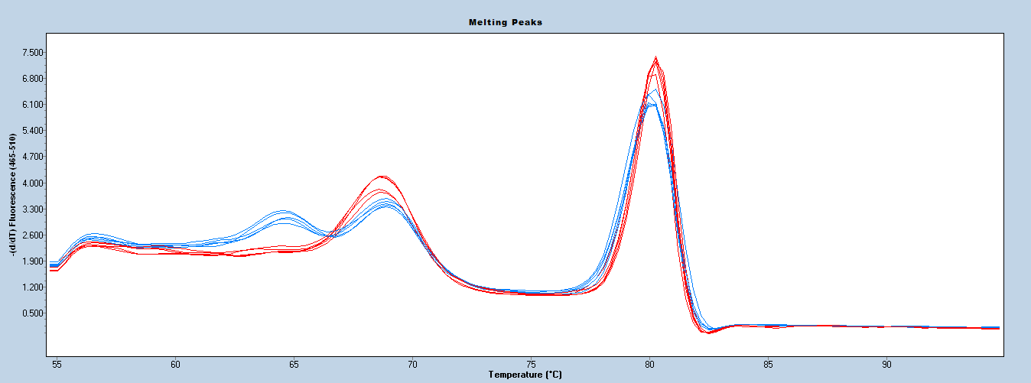

Susceptibility (h2)

Resistance (H2)

**UFPc2H2HRM01 Figure 1.** Melting curve patterns derived by the HRM analysis using UFPc2H2HRM01. **A)** Phytophthora crown rot resistance (H2) curve pattern; **B)** Phytophthora crown rot susceptibility (h2) curve pattern

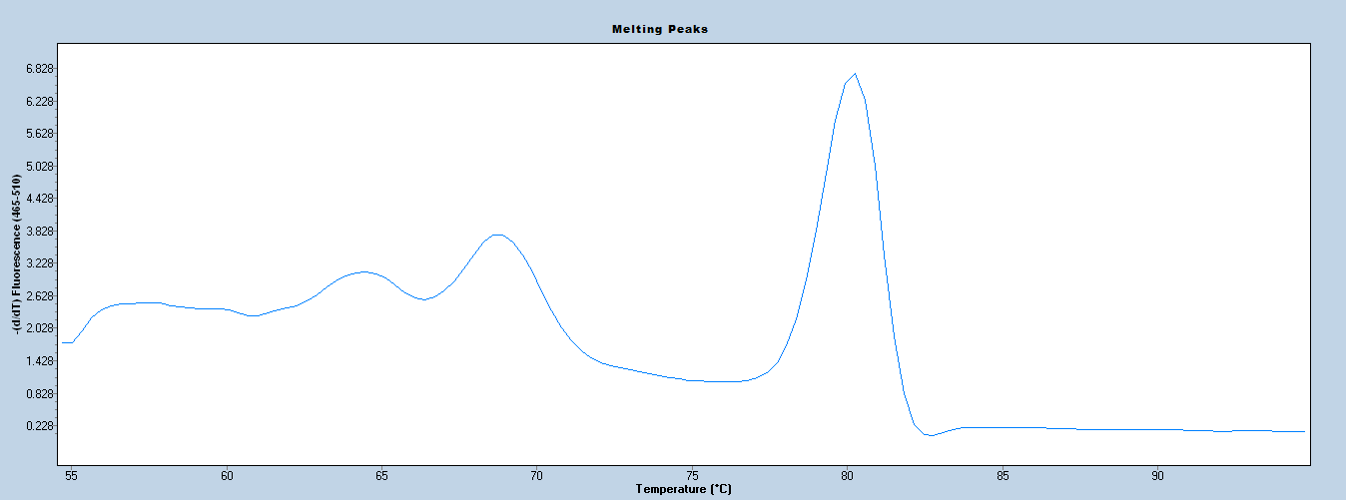

**Pc2 resistance (H2)**

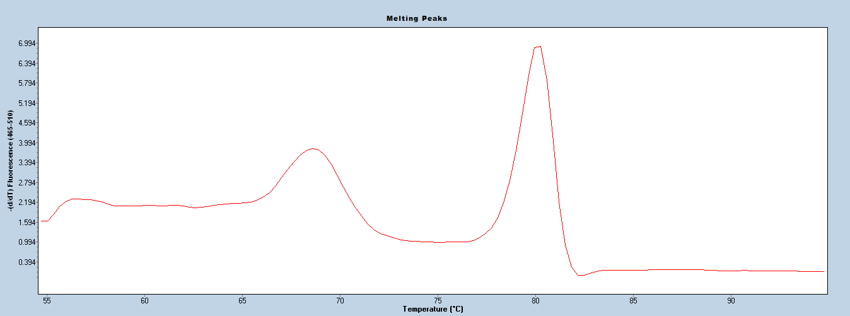

**Pc2 susceptibility (h2)**

**A**

**B**

**-(d/dT) Fluorescence (465-510)**

**Additional Notes**

This H2 marker can be effectively detect the resistant accessions containing the resistance H2 allele (Noh et al., 2018). The UFPc2H2HRM01 can be multiplexed with the UFCa1HRM02 primer set for Anthracnose fruit rot resistance (*FaRCa1*). Control samples should always be used with HRM analysis to identify the melt clusters.

### FaRPc2 - H2 (UFPc2H2HRM03) – Unpublished marker

**Background**

* A test for *Phytophthora cactorum* crown rot resistance.
* Targets only one of two haplotypes (the *FaRPc2* H2haplotype on chromosome 7-3) associated with resistance.
* This codominant marker has been shown to be predictive in germplasm originating from the University of Florida breeding program.

**Technical Details**

***Primer Sequences***

|  |  |
| --- | --- |
| **Primer** | **Sequence** |
| UFPc2H2HRM03-F | Not available yet (unpublished data) |
| UFPc2H2HRM03-R |

Physical locations of primers in octoploid reference genome (cv. Camarosa)

UFPc2HRM03-F: Not available yet

UFPc2HRM03-R: Not available yet

***Reaction Master Mix***

|  |  |  |
| --- | --- | --- |
| **Component** | **Concentration** | **Amount for 1 reaction (μL)** |
| AccuStartTM II PCR ToughMix®a | 2X | 2.5 |
| UFPc2H2HRM03-F | 5 μM | 0.75 |
| UFPc2H2HRM03-R | 5 μM | 0.75 |
| LCGreen® Plusb |  | 0.25 |
| Sterile PCR water |  | 0.75 |
| DNA | 50 ng/μL | 0.5 |
| **Total** |  | 5.5 |

aQuantabio (catalog number: 95142-100, 95142-800, or 95142-04K)

bBioFire Defense (catalog number: BCHM-ASY-0005 or BCHM-ASY-0006)

***PCR Program***

|  |  |  |  |
| --- | --- | --- | --- |
| **Temperature (°C)** | **Time (mm:ss)** | **Cycles** | **Process** |
| 95 | 3:00 |  |  |
| 95 | 0:10 |  | PCR |
| **62** | 0:10 | 45 |  |
| 72 | 0:10 |  |  |
| 95 | 1:00 |  | HRM |
| 55 | 1:00 |  |  |
| 95 | Continuous |  |  |
| 40 | 0:30 |  |  |
| 4 | Hold |  |  |

The PCR and HRM analysis were performed in a LightCycler® 480 (Roche Life Science).

**Interpretation**

|  |  |  |
| --- | --- | --- |
| **Predicted Trait** | **Alleles** | **Examples** |
| Phytophthora crown rot resistance  (H2 allele) or susceptibility | *FaRPc2-H2* | Grenada (S), Petaluma (S),  Sweet Sensation® ‘Florida 127’ (S),  Florida Elyana (R) |
| Phytophthora crown rot resistance (H3 allele) or susceptibility | *farpc2-h2* | Camarosa, Florida Beauty, Florida Brilliance,  Fronteras, Monterey, Portola, Strawberry Festival |

**UFPc2H2HRM03 Figure 1.** Melting curve patterns derived by the HRM analysis using UFPc2H2HRM03. In the melting curves analysis, phytophthora crown rot homozygous and heterozygous resistance accessions are shown in blue and green curve pattern, respectively, and susceptibility accessions shown red curve pattern.

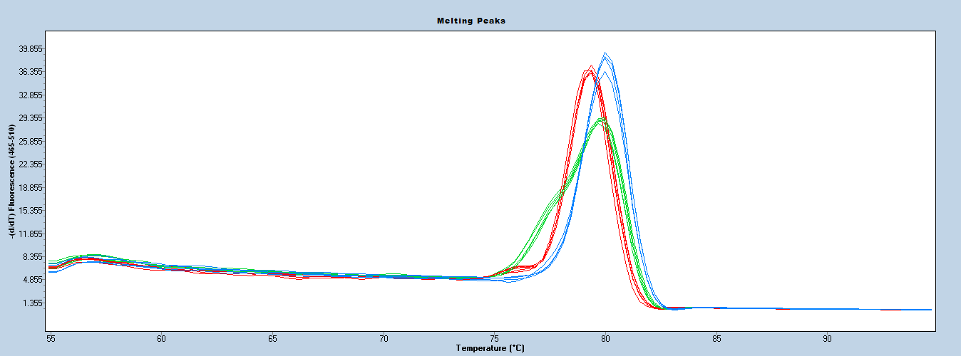

H2 resistance (Heterozygous)

Susceptibility

H2 resistance (Homozygous)

**Additional Notes**

The codominant H2 marker, UFPc2HRM03, can be effectively detect the resistant accessions containing the homozygote and heterozygote resistance H2 allele. Control samples should always be used with HRM analysis to identify the melt clusters. This marker works well with crude DNA prepared by NaOH based rapid extraction.

### FaRPc2 - H3 (UFPc2H3HRM02)

**Background**

* A test for *Phytophthora cactorum* crown rot resistance.
* Targets only one of two haplotypes (the *FaRPc2* H3haplotype on chromosome 7d) associated with resistance.
* The marker has been shown to be predictive in germplasm originating from the University of Florida breeding program.

**Technical Details**

***Primer Sequences***

|  |  |
| --- | --- |
| **Primer** | **Sequence** |
| UFPc2H3HRM02-F | TCAGAAAACCGTGGAAGCAAA |
| UFPc2H3HRM02-R | GAACTTGACACCGGAGCATCT |
| UFPc2H3HRM02-F-probe | TCAGCTGGTGTTGAAGTCTGATGCA/3SpC3/ |

Physical locations of primers in octoploid reference genome (cv. Camarosa)

UFPc2HRM02-F: 2,302,555 bp

UFPc2HRM02-R: 2,302,653 bp

***Reaction Master Mix***

|  |  |  |
| --- | --- | --- |
| **Component** | **Concentration** | **Amount for 1 reaction (μL)** |
| AccuStartTM II PCR ToughMix®a | 2X | 2.5 |
| UFPc2H3HRM02-F | 5 μM | 0.1 |
| UFPc2H3HRM02-R | 5 Μm | 0.5 |
| UFPc2H3HRM02-F-probe | 5 μM | 0.5 |
| LCGreen® Plusb |  | 0.25 |
| Sterile PCR water |  | 1.15 |
| DNA | 50 ng/μL | 0.5 |
| **Total** |  | 5.5 |

aQuantabio (catalog number: 95142-100, 95142-800, or 95142-04K)

bBioFire Defense (catalog number: BCHM-ASY-0005 or BCHM-ASY-0006)

***PCR Program***

|  |  |  |  |
| --- | --- | --- | --- |
| **Temperature (°C)** | **Time (mm:ss)** | **Cycles** | **Process** |
| 95 | 3:00 |  |  |
| 95 | 0:10 |  | PCR |
| 62 | 0:10 | 45 |  |
| 72 | 0:10 |  |  |
| 95 | 1:00 |  | HRM |
| 55 | 1:00 |  |  |
| 95 | Continuous |  |  |
| 40 | 0:30 |  |  |
| 4 | Hold |  |  |

The PCR and HRM analysis were performed in a LightCycler® 480 (Roche Life Science).

**Interpretation**

|  |  |  |
| --- | --- | --- |
| **Predicted Trait** | **Alleles** | **Examples** |
| Phytophthora crown rot resistance | *FaRPc2* | Camarosa, Florida Beauty, Florida Elyana, Strawberry Festival |
| Phytophthora crown rot susceptibility | *farpc2* | Florida Brilliance, Sweet Sensation® ‘Florida 127’, Winter Dawn, Winter Star |

**UFPc2H3HRM02 Figure 1.** Melting curve patterns derived by the HRM analysis using UFPc2H3HRM02. **A)** Phytophthora crown rot resistance (H3) curve pattern; **B)** Phytophthora crown rot susceptibility (h3) curve pattern

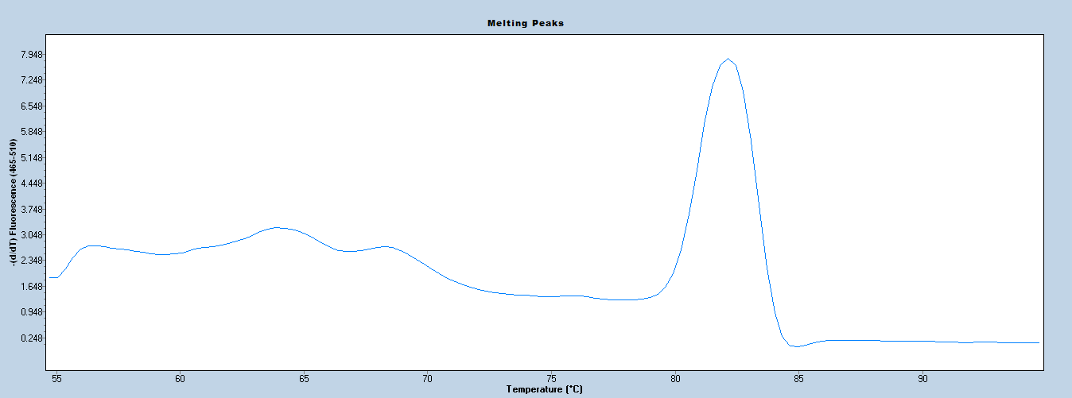

**Pc2 resistance (H3)**

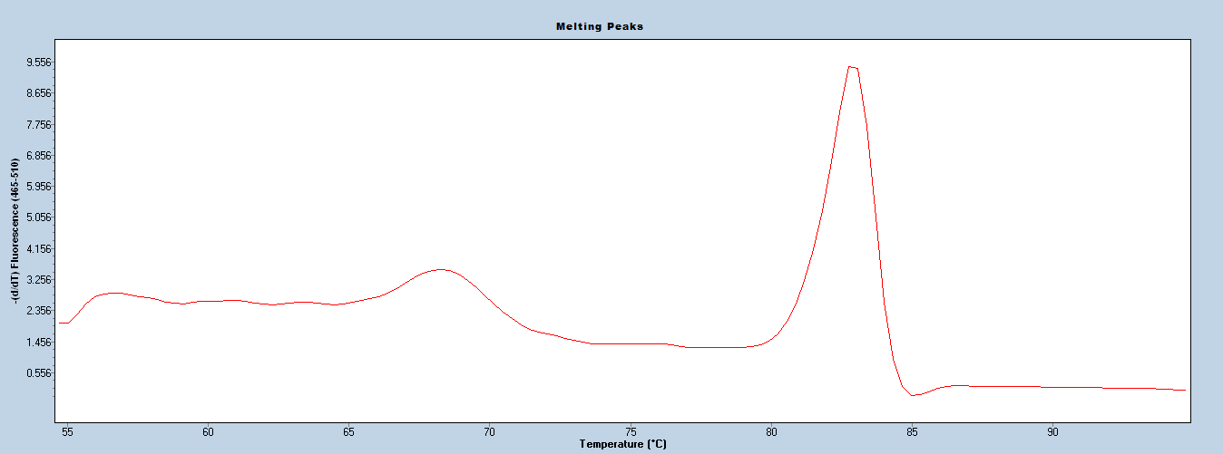

**Pc2 susceptibility (h3)**

**A**

**B**

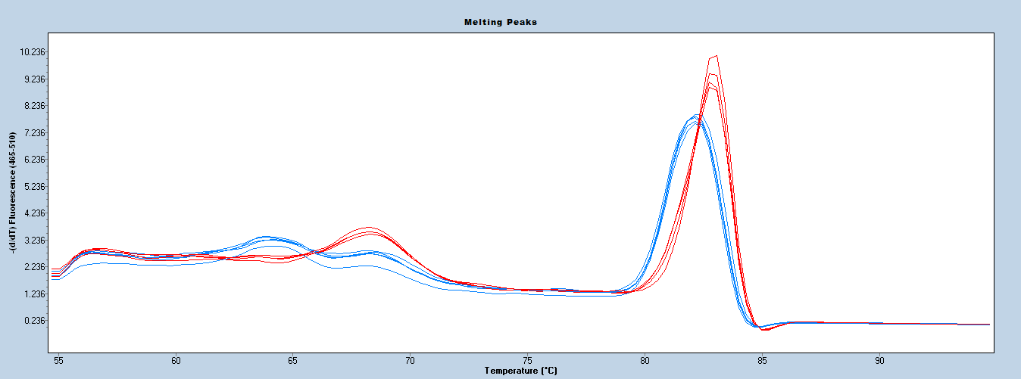

Resistance (H3)

Susceptibility (h3)

**UFPc2H3HRM02 Figure 2.** Melting curve patterns derived by the HRM analysis using UFPc2HRM02. In melting curves analysis, phytophthora crown rot resistance (H3) and susceptibility (h3) accessions shown blue and red curve pattern, respectively.

**Additional Notes**

This marker, UFPc2H3HRM02, can effectively detect strawberry accessions resistant to *P. cactorum* pathogen due to the presence of resistance H3 allele (Noh et al., 2018). The UFPc2H3HRM02 can be multiplexed with the UFCa1HRM02 primer set for the anthracnose fruit rot resistance (*FaRCa1*). Control samples should always be used with HRM analysis to identify the melt clusters. This marker works well with crude DNA prepared by NaOH based rapid extraction.

### FaRPc2 - H3 (UFPc2H3HRM04) – Unpublished marker

**Background**

* A test for *Phytophthora cactorum* crown rot resistance.
* Targets only one of two haplotypes (the *FaRPc2* H3haplotype on chromosome 7-3) associated with resistance.
* The marker has been shown to be predictive in germplasm originating from the University of Florida breeding program.

**Technical Details**

***Primer Sequences***

|  |  |
| --- | --- |
| **Primer** | **Sequence** |
| UFPc2H3HRM04-F | Not available yet (unpublished data) |
| UFPc2H3HRM04-R |

Physical locations of primers in octoploid reference genome (cv. Camarosa)

UFPc2HRM04-F: Not available yet

UFPc2HRM04-R: Not available yet

***Reaction Master Mix***

|  |  |  |
| --- | --- | --- |
| **Component** | **Concentration** | **Amount for 1 reaction (μL)** |
| AccuStartTM II PCR ToughMix®a | 2X | 2.5 |
| UFPc2HRM02-F | 5 μM | 0.1 |
| UFPc2HRM02-R | 5 Μm | 0.5 |
| LCGreen® Plusb |  | 0.25 |
| Sterile PCR water |  | 1.15 |
| DNA | 50 ng/μL | 0.5 |
| **Total** |  | 5.5 |

aQuantabio (catalog number: 95142-100, 95142-800, or 95142-04K)

bBioFire Defense (catalog number: BCHM-ASY-0005 or BCHM-ASY-0006)

***PCR Program***

|  |  |  |  |
| --- | --- | --- | --- |
| **Temperature (°C)** | **Time (mm:ss)** | **Cycles** | **Process** |
| 95 | 3:00 |  |  |
| 95 | 0:10 |  | PCR |
| 62 | 0:10 | 45 |  |
| 72 | 0:10 |  |  |
| 95 | 1:00 |  | HRM |
| 55 | 1:00 |  |  |
| 95 | Continuous |  |  |
| 40 | 0:30 |  |  |
| 4 | Hold |  |  |

The PCR and HRM analysis were performed in a LightCycler® 480 (Roche Life Science).

**Interpretation**

|  |  |  |
| --- | --- | --- |
| **Predicted Trait** | **Alleles** | **Examples** |
| Phytophthora crown rot resistance | *FaRPc2* | Camarosa, Florida Beauty, Florida Elyana, Strawberry Festival |
| Phytophthora crown rot susceptibility | *farpc2* | Florida Brilliance, Sweet Sensation® ‘Florida 127’, Winter Dawn, Winter Star |

**UFPc2H3HRM04 Figure 1.** Melting curve patterns derived by the HRM analysis using UFPc2H3HRM04. In the melting curves analysis, phytophthora crown rot homozygous and heterozygous resistance accessions are shown in blue and green curve pattern, respectively, and susceptibility accessions shown red curve pattern.

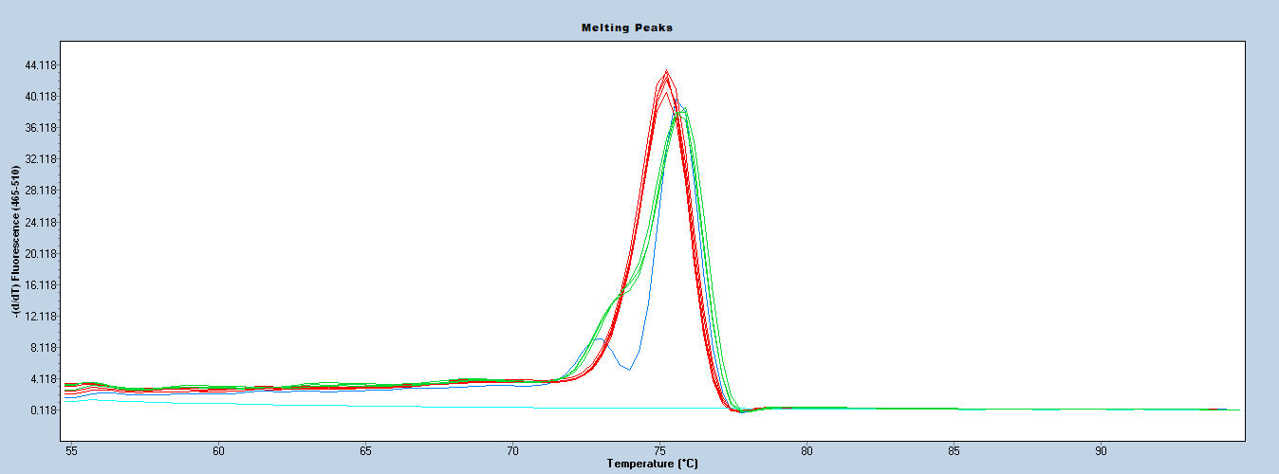

H2 resistance (Hetero)

Susceptibility

H2 resistance (Homo)

**Additional Notes**

The codominant H3 marker, UFPc2H3HRM04, can be effectively detect the resistant accessions containing the homozygote and heterozygote resistance H3 allele. Control samples should always be used with HRM analysis to identify the melt clusters. This marker works well with crude DNA prepared by NaOH based rapid extraction.

### FaRPc2 - H3 (RPCKASPH3)

**Background**

* A test for *Phytophthora cactorum* crown rot resistance.
* Targets only one of two haplotypes (the *FaRPc2* haplotype 3on chromosome 7-3) associated with resistance.
* The marker was designed by Noh et al., (2018) and has been shown to be predictive in germplasm originating from UC Davis and the University of Florida breeding program.

**Technical Details**

***Primer Sequences***

RPCKASPH3 primer mix can be ordered through LGC Genomics. Primers are labeled on the 5’ end.

|  |  |
| --- | --- |
| **Primer** | **Sequence** |
| RPCKASPH3-FAM | GAAGGTGACCAAGTTCATGCT / TCTGCATCAGACTTCAACACCAGT |
| RPCKASPH3-HEX | GAAGGTCGGAGTCAACGGATT / CTGCATCAGACTTCAACACCAGC |
| RPCKASPH3-R | ATATTATTTTAGCATCAAATCAGAAAACCG |

FAM or HEX tailed-sequences (underlined) and annealing sequences are divided by a slash.

***Reaction Master Mix***

|  |  |  |
| --- | --- | --- |
| **Component** | **Concentration** | **Amount for 1 reaction (μL)** |
| KASP master mixab | 2X | 5 |
| RPCKASPH3 primer mix | 1X | 0.15 |
| ddH2O |  | 1.85 |
| DNA | 100 ng/μL | 3 |
| **Total** |  | 15 |

aLGC (Catalog Number: KBS-1030-001)

bMultiple catalog numbers exist each optimized for the thermocycler being used. Check with LGC to determine the correct master mix for your equipment.

***PCR Program***

|  |  |  |
| --- | --- | --- |
| **Temperature (°C)** | **Time (mm:ss)** | **Cycles** |
| 94 | 15:00 |  |
| 94 | 0:20 |  |
| 61-0.6 °C/cycle | 1:00 | 10 |
| 94 | 0:20 |  |
| 55 | 1:00 | 30 |
| 37 | 1:00 |  |
| Plate Read |  |  |

***Optional: PCR program to re-read samples after initial program if cluster resolution is poor***

|  |  |  |
| --- | --- | --- |
| **Temperature (°C)** | **Time (mm:ss)** | **Cycles** |
| 94 | 0:20 |  |
| 57 | 1:00 | 3 |
| 37 | 1:00 |  |
| Plate Read |  |  |

**Interpretation**

|  |  |  |
| --- | --- | --- |
| **Predicted Trait** | **Alleles** | **Examples** |
| Phytophthora Crown rot resistance | A\A (H3) | Strawberry Festival |
| Phytophthora Crown rot resistance | A\G (Het for H3) |  |
| Phytophthora Crown rot susceptibility | G\G (non-H3) | Winter Dawn |



**RPCKASPH3 Figure 1.** Example of homozygous and heterozygous clusters for RPCKASPH3.

**Additional Notes**

The distribution of *Phytophthora cactorum* races has not been well studied. Races which are virulent on *FaRPc2* may be predominant in some growing regions. This KASP marker does not work well with crude DNA prepared by NaOH based rapid extraction (Noh et al., 2017 and 2018).

### FaRXf1 (HRM6D_33.083)

**Background**

* A test for angular leaf spot (*Xanthomonas fragariae*)resistance.
* Target only one (the *FaRXf1* haplotype on chromosome 6-2) associated with resistance.
* The marker was designed by Raoch et al., (2016) and has been shown to be predictive in germplasm originating from University of Florida breeding program.

**Technical Details**

***Primer Sequences***

|  |  |
| --- | --- |
| **Primer** | **Sequence** |
| HRM6D_33.083 -F | TGCAAGCACGAACAACATCAGC |
| HRM6D_33.083 -R | GTTTGGATGATTTGGCCTATGC |

Physical locations of primers in octoploid reference genome (cv. Camarosa)

HRM6D_33.083 -F: 31,000,240 bp

HRM6D_33.083 -R: 31,000,154 bp

***Reaction Master Mix***

|  |  |  |
| --- | --- | --- |
| **Component** | **Concentration** | **Amount for 1 reaction (μL)** |
| AccuStartTM II PCR ToughMix®a | 2X | 2.5 |
| Primer Mix (F+R) | 5 μM | 1.5 |
| LCGreen® Plusb |  | 0.25 |
| Sterile PCR water |  | 0.75 |
| DNA | 50 ng/μL | 0.5 |
| **Total** |  | 5.5 |

aQuantabio (catalog number: 95142-100, 95142-800, or 95142-04K)

bBioFire Defense (catalog number: BCHM-ASY-0005 or BCHM-ASY-0006)

***PCR Program***

|  |  |  |  |
| --- | --- | --- | --- |
| **Temperature (°C)** | **Time (mm:ss)** | **Cycles** | **Process** |
| 95 | 3:00 |  |  |
| 95 | 0:10 |  | PCR |
| 62 | 0:10 | 35 |  |
| 72 | 0:10 |  |  |
| 95 | 1:00 |  | HRM |
| 55 | 1:00 |  |  |
| 95 | Continuous |  |  |
| 40 | 0:30 |  |  |
| 4 | Hold |  |  |

The PCR and HRM analysis were performed in a LightCycler® 480 (Roche Life Science).

**Interpretation**

|  |  |  |
| --- | --- | --- |
| **Predicted Trait** | **Alleles** | **Examples** |
| Angular leaf spot resistance | *FaRXf1* | 14.101-225, US4808, US4809 |
| Angular leaf spot susceptibility | *farxf1* | Camarosa, Florida Brilliance, Florida Elyana, Florida Radiance, Strawberry Festival, Sweet Sensation® ‘Florida 127’,  Winter Star |

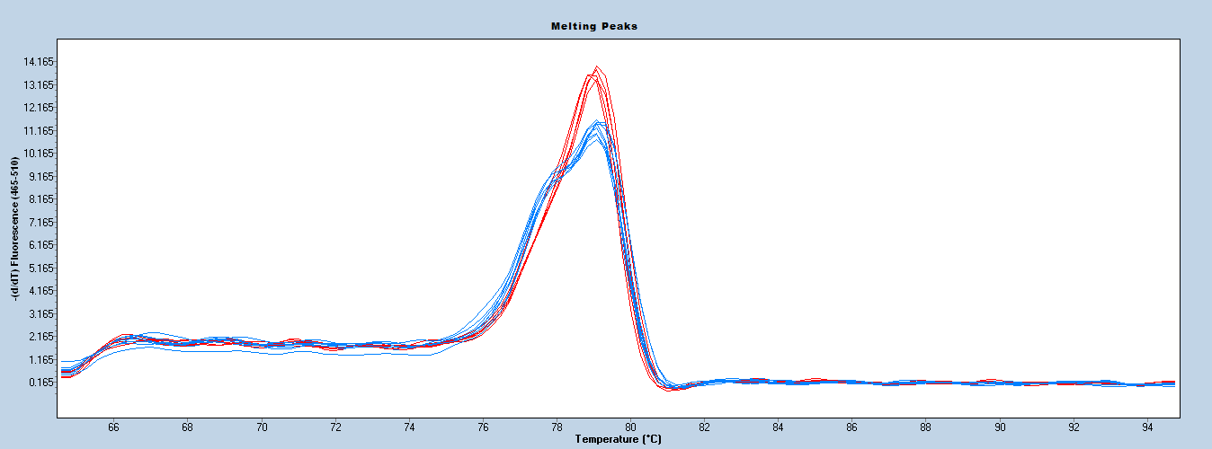

Resistance

Susceptibility

**HRM6D_33.083 Figure 1.** Melting curve patterns derived by the HRM analysis using HRM6D_33.083. In melting curves analysis, angular leaf spot resistance and susceptibility accessions shown blue and red curve pattern, respectively.

**Additional Notes**

This marker can detect accessions containing *FaRXf1* resistant locus (Roach et al., 2016). Control samples should always be used with HRM analysis to identify the melt clusters. This marker does not work well with crude DNA prepared by NaOH based rapid extraction.

### FaRXf1 (**UFXf1HRM01) – Unpublished marker**

**Background**

* A test for angular leaf spot (*Xanthomonas fragariae*)resistance.
* Target only one (the *FaRXf1* haplotype on chromosome 6-2) associated with resistance.
* The marker has been shown to be predictive in germplasm originating from the University of Florida breeding program.

**Technical Details**

***Primer Sequences***

|  |  |
| --- | --- |
| **Primer** | **Sequence** |
| UFXf1HRM01-F | Not available yet (unpublished data) |
| UFXf1HRM01-R |

Physical locations of primers in octoploid reference genome (cv. Camarosa)

UFXf1HRM01-F: Not available yet

UFXf1HRM01-R: Not available yet

***Reaction Master Mix***

|  |  |  |
| --- | --- | --- |
| **Component** | **Concentration** | **Amount for 1 reaction (μL)** |
| AccuStartTM II PCR ToughMix®a | 2X | 2.5 |
| Primer Mix (F+R) | 5 μM | 1.0 |
| LCGreen® Plusb |  | 0.25 |
| Sterile PCR water |  | 1.25 |
| DNA | 50 ng/μL | 0.5 |
| **Total** |  | 5.5 |

aQuantabio (catalog number: 95142-100, 95142-800, or 95142-04K)

bBioFire Defense (catalog number: BCHM-ASY-0005 or BCHM-ASY-0006)

***PCR Program***

|  |  |  |  |
| --- | --- | --- | --- |
| **Temperature (°C)** | **Time (mm:ss)** | **Cycles** | **Process** |
| 95 | 3:00 |  |  |
| 95 | 0:10 |  | PCR |
| 62 | 0:10 | 45 |  |
| 72 | 0:10 |  |  |
| 95 | 1:00 |  | HRM |
| 55 | 1:00 |  |  |
| 95 | Continuous |  |  |
| 40 | 0:30 |  |  |
| 4 | Hold |  |  |

The PCR and HRM analysis were performed in a LightCycler® 480 (Roche Life Science).

**Interpretation**

|  |  |  |
| --- | --- | --- |
| **Predicted Trait** | **Alleles** | **Examples** |
| Angular leaf spot resistance | *FaRXf1* | 14.101-225, US4808, US4809 |
| Angular leaf spot susceptibility | *farxf1* | Camarosa, Florida Brilliance, Florida Elyana, Florida Radiance, Strawberry Festival, Sweet Sensation® ‘Florida 127’,  Winter Star |

**UFXf1HRM001 Figure 1.** Melting curve patterns derived by the HRM analysis using UFXf1HRM001. In melting curves analysis, angular leaf spot resistance and susceptibility accessions shown blue and red curve pattern, respectively.

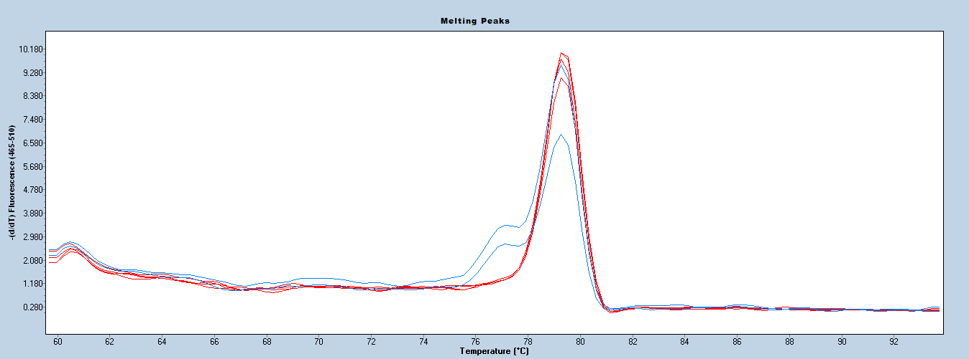

Resistance

Susceptibility

**Additional Notes**

This marker can detect accessions containing *FaRXf1* resistant locus (Roach et al., 2016). Control samples should always be used with HRM analysis to identify the melt clusters. This marker works well with crude DNA prepared by NaOH based rapid extraction.

### FaRXf1 (**UFXf1HRM02) – Unpublished marker**

**Background**

* A test for angular leaf spot (*Xanthomonas fragariae*)resistance.
* Target only one (the *FaRXf1* haplotype on chromosome 6-2) associated with resistance.
* The marker has been shown to be predictive in germplasm originating from the University of Florida breeding program.

**Technical Details**

***Primer Sequences***

|  |  |
| --- | --- |
| **Primer** | **Sequence** |
| UFXf1HRM02-F | Not available yet (unpublished data) |
| UFXf1HRM02-R |

Physical locations of primers in octoploid reference genome (cv. Camarosa)

UFXf1HRM02-F: Not available yet

UFXf1HRM02-R: Not available yet

***Reaction Master Mix***

|  |  |  |
| --- | --- | --- |
| **Component** | **Concentration** | **Amount for 1 reaction (μL)** |
| AccuStartTM II PCR ToughMix®a | 2X | 2.5 |
| Primer Mix (F+R) | 5 μM | 1.0 |
| LCGreen® Plusb |  | 0.25 |
| Sterile PCR water |  | 1.25 |
| DNA | 50 ng/μL | 0.5 |
| **Total** |  | 5.5 |

aQuantabio (catalog number: 95142-100, 95142-800, or 95142-04K)

bBioFire Defense (catalog number: BCHM-ASY-0005 or BCHM-ASY-0006)

***PCR Program***

|  |  |  |  |
| --- | --- | --- | --- |
| **Temperature (°C)** | **Time (mm:ss)** | **Cycles** | **Process** |
| 95 | 3:00 |  |  |
| 95 | 0:10 |  | PCR |
| 62 | 0:10 | 45 |  |
| 72 | 0:10 |  |  |
| 95 | 1:00 |  | HRM |
| 55 | 1:00 |  |  |
| 95 | Continuous |  |  |
| 40 | 0:30 |  |  |
| 4 | Hold |  |  |

The PCR and HRM analysis were performed in a LightCycler® 480 (Roche Life Science).

**Interpretation**

|  |  |  |
| --- | --- | --- |
| **Predicted Trait** | **Alleles** | **Examples** |
| Angular leaf spot resistance | *FaRXf1* | 14.101-225, US4808, US4809 |
| Angular leaf spot susceptibility | *farxf1* | Camarosa, Florida Brilliance, Florida Elyana, Florida Radiance, Strawberry Festival, Sweet Sensation® ‘Florida 127’,  Winter Star |

**UFXf1HRM002 Figure 1.** Melting curve patterns derived by the HRM analysis using UFXf1HRM002. In melting curves analysis, angular leaf spot resistance and susceptibility accessions shown blue and red curve pattern, respectively.

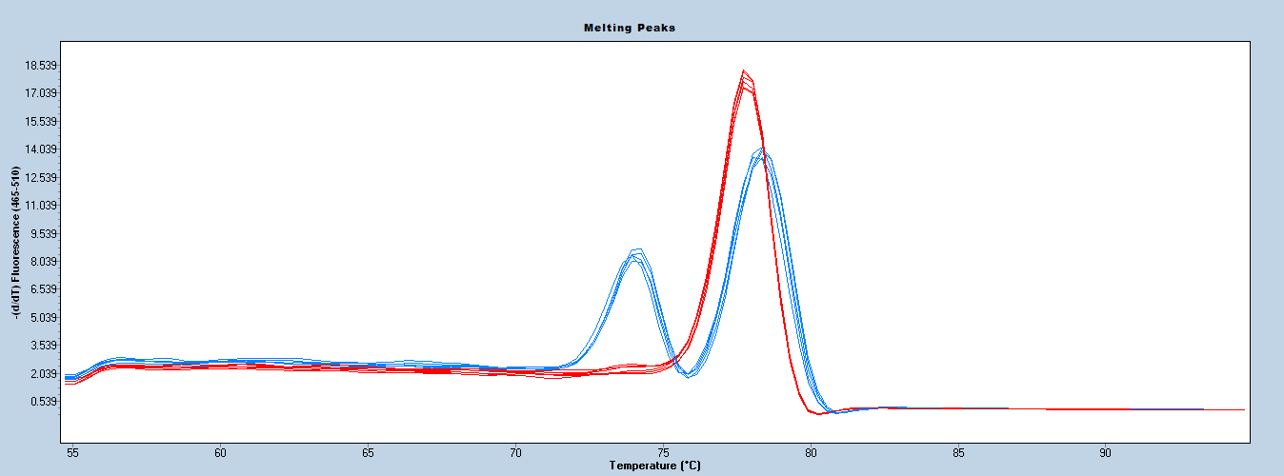

Resistance

Susceptibility

**Additional Notes**

This marker can detect accessions containing *FaRXf1* resistant locus (Roach et al., 2016). Control samples should always be used with HRM analysis to identify the melt clusters. This marker works well with crude DNA prepared by NaOH based rapid extraction.

### FaRCa1 (UFCa1HRM01) – Unpublished marker

**Background**

* A test for Anthracnose fruit rot (*Colletotrichum acutatum*)resistance.
* Target only one haplotypes (AX-89838986 on chromosome 6-3) associated with resistance.
* This codominant marker has been shown to be predictive in germplasm originating from the University of Florida breeding program.

**Technical Details**

***Primer Sequences***

|  |  |
| --- | --- |
| **Primer** | **Sequence** |
| UFCa1HRM01-F | Not available yet (unpublished data) |
| UFCa1HRM01-R |

Physical locations of primers in octoploid reference genome (cv. Camarosa)

UFCa1HRM01-F: Not available yet

UFCa1HRM01-R: Not available yet

***Reaction Master Mix***

|  |  |  |
| --- | --- | --- |
| **Component** | **Concentration** | **Amount for 1 reaction (μL)** |
| AccuStartTM II PCR ToughMix®a | 2X | 2.5 |
| UFCa1HRM01-F | 5 μM | 0.5 |
| UFCa1HRM01-R | 5 μM | 0.5 |
| LCGreen® Plusb |  | 0.25 |
| Sterile PCR water |  | 1.25 |
| DNA | 50 ng/μL | 0.5 |
| **Total** |  | 5.5 |

aQuantabio (catalog number: 95142-100, 95142-800, or 95142-04K)

bBioFire Defense (catalog number: BCHM-ASY-0005 or BCHM-ASY-0006)

***PCR Program***

|  |  |  |  |
| --- | --- | --- | --- |
| **Temperature (°C)** | **Time (mm:ss)** | **Cycles** | **Process** |
| 95 | 3:00 |  |  |
| 95 | 0:10 |  | PCR |
| 60 | 0:10 | 45 |  |
| 72 | 0:10 |  |  |
| 95 | 1:00 |  | HRM |
| 55 | 1:00 |  |  |
| 95 | Continuous |  |  |
| 40 | 0:30 |  |  |
| 4 | Hold |  |  |

The PCR and HRM analysis were performed in a LightCycler® 480 (Roche Life Science).

**Interpretation**

|  |  |  |
| --- | --- | --- |
| **Predicted Trait** | **Alleles** | **Examples** |
| Anthracnose fruit rot resistance | *FaRCa1* | Florida Brilliance, Florida Elyana, Florida Radiance, Sweet Sensation® ‘Florida 127’, Winter Star |
| Anthracnose fruit rot susceptibility | *farca1* | Camarosa, Florida Beauty, Strawberry Festival |

**UFCa1HRM01 Figure 1.** Melting curve patterns derived by the HRM analysis using UFCa1HRM01. In the melting curves analysis, Anthracnose fruit rot homozygous and heterozygous resistance accessions are shown in green and blue curve pattern, respectively, and susceptibility accessions shown red curve pattern.

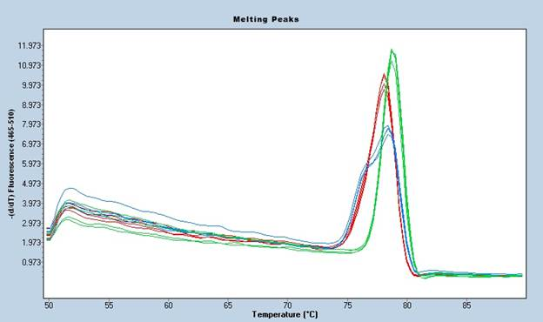

H2 resistance (Hetero)

Susceptibility

H2 resistance (Homo)

**Additional Notes**

The distribution of Colletotrichum acutatum pathogenic groups has not been well studied. This locus is effective against this pathogen (Salinas et al., 2018). The codominant Ca1 marker, UFCa1HRM01, can be effectively detect the resistant accessions containing the homozygote and heterozygote resistance allele. Control samples should always be used with HRM analysis to identify the melt clusters. This marker does not work well with crude DNA prepared by NaOH based rapid extraction.

### FaRCg1 (**UFCg1HRM01) – Unpublished marker**

**Background**

* A test for Colletotrichum crown rot (*Colletotrichum gloeosporioides*)resistance.
* Target only one (the *FaRCg11* haplotype on chromosome 6-3) associated with resistance.
* The marker has been shown to be predictive in germplasm originating from the University of Florida breeding program.

**Technical Details**

***Primer Sequences***

|  |  |
| --- | --- |
| **Primer** | **Sequence** |
| UFCg1HRM01-F | Not available yet (unpublished data) |
| UFCg1HRM01-R |

Physical locations of primers in octoploid reference genome (cv. Camarosa)

UFCg1HRM01-F: Not available yet

UFCg1HRM01-R: Not available yet

***Reaction Master Mix***

|  |  |  |
| --- | --- | --- |
| **Component** | **Concentration** | **Amount for 1 reaction (μL)** |
| AccuStartTM II PCR ToughMix®a | 2X | 2.5 |
| Primer Mix (F+R) | 5 μM | 1.0 |
| LCGreen® Plusb |  | 0.25 |
| Sterile PCR water |  | 1.25 |
| DNA | 50 ng/μL | 0.5 |
| **Total** |  | 5.5 |

aQuantabio (catalog number: 95142-100, 95142-800, or 95142-04K)

bBioFire Defense (catalog number: BCHM-ASY-0005 or BCHM-ASY-0006)

***PCR Program***

|  |  |  |  |
| --- | --- | --- | --- |
| **Temperature (°C)** | **Time (mm:ss)** | **Cycles** | **Process** |
| 95 | 3:00 |  |  |
| 95 | 0:10 |  | PCR |
| **62** | 0:10 | 45 |  |
| 72 | 0:10 |  |  |
| 95 | 1:00 |  | HRM |
| 55 | 1:00 |  |  |
| 95 | Continuous |  |  |
| 40 | 0:30 |  |  |
| 4 | Hold |  |  |

The PCR and HRM analysis were performed in a LightCycler® 480 (Roche Life Science).

**Interpretation**

|  |  |  |
| --- | --- | --- |
| **Predicted Trait** | **Alleles** | **Examples** |
| Colletotrichum Crown rot resistance | *FaRCg1* | Florida Elyana, Winter Dawn, FL10-128,  FL10-129 |
| Colletotrichum Crown rot susceptibility | *farcg1* | Camarosa, Florida Beauty, Strawberry Festival,  Sweet Sensation® ‘Florida 127’, Winter star |

**UFCg1HRM01 Figure 1.** Melting curve patterns derived by the HRM analysis using UFCg1HRM01. In melting curves analysis, Fusarium wilt resistance and susceptibility accessions shown blue and red curve pattern, respectively.

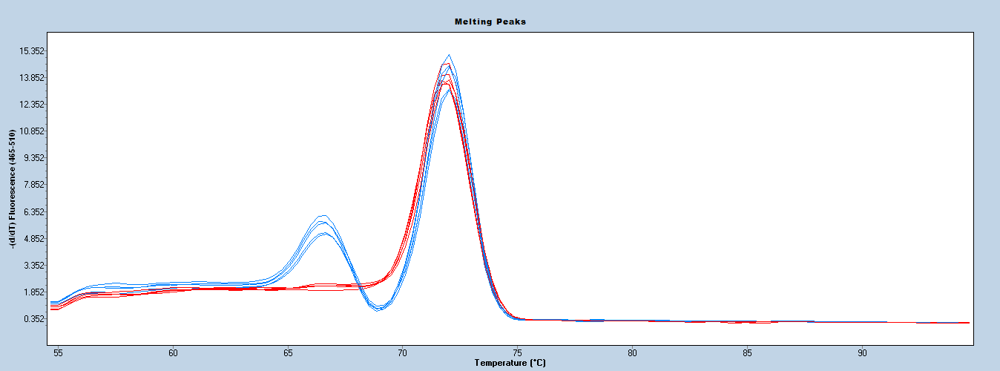

Resistance

Susceptibility

**Additional Notes**

Control samples should always be used with HRM analysis to identify the melt clusters. This marker works well with crude DNA prepared by NaOH based rapid extraction.

# **Multiplex Protocols**

### FaFAD1 (qFaFAD1) + FaOMT (FaOMTSI/NO)

**Background**

* A test for γ-decalactone and mesifurane content in fruit.
* Targets *FaFAD1* on chromosome 3b associated with a severe reduction/absence of γ-decalactone.
* The qFaFAD1 marker was designed by Sánchez-Sevilla et al., (2014) and is a perfect dominant marker.
* Targets FaOMT on chromosome 7b associated with a severe reduction in mesifurane content.
* The FaOMTSI/NO marker was designed by Zorrilla-Fontanesi et al., (2012) and is a perfect marker.

**Technical Details**

***Primer Sequences***

|  |  |
| --- | --- |
| **Primer** | **Sequence** |
| qFaFAD1-F | TCTGTACTCTACCGCCTTGC |
| qFaFAD1-R | TCGTAGTGTGGCAGTGAAGG |
| FaOMTSI/NO-F | CGATCATTTCGAAAAGGACTAGT |
| FaOMTSI/NO-R | AAGCAGGGTTAGTTGTGGAGA |

***Reaction Master Mix***

|  |  |  |
| --- | --- | --- |
| **Componenta** | **Concentration** | **Amount for 1 reaction (μL)** |
| PCR Buffer | 5X | 3 |
| MgCl2 | 25 mM | 1.2 |
| dNTP’s | 2.5 mM | 1.2 |
| qFaFAD1-F | 10 μM | 0.15 |
| qFaFAD1-R | 10 μM | 0.15 |
| Taq |  | 0.2 |
| ddH2O |  | 6.1 |
| DNA | 3 ng/μL | 3 |
| **Total** |  | 15 |

aPromega (catalog number: M5001, M5005, M5006, or M5008)

***PCR Program***

|  |  |  |
| --- | --- | --- |
| **Temperature (°C)** | **Time (mm:ss)** | **Cycles** |
| 95 | 3:00 |  |
| 95 | 0:30 |  |
| 55 | 0:30 | 35 |
| 72 | 0:45 |  |
| 60 | 7:00 |  |
| 4 | hold |  |

The test is visualized via 3% agarose.

**Interpretation**

|  |  |  |
| --- | --- | --- |
| **Predicted Trait** | **Alleles** | **Examples** |
| *γ-decalactone Produced* | 140 bp allele present | Florida Radiance, Sweet Sensation, Winterstar |
| *γ-decalactone Not Produced* | 140 bp allele absent | Camarosa, Mara des Bois, Winter Dawn |
| *Mesifurane Produced* | 248/248 bp | Mara des Bois, Monterrey |
| *Mesifurane Produced* | 217/248 bp | Camarosa, Strawberry Festival, Sweet Charlie, Winterstar |
| *Mesifurane Not Produced* | 217/217 bp | Deutsch Evern, Hood |



**qFaFAD1 + FaOMTSI/NO Figure 1.** Example of a multiplexed gel interpretation

**Additional Notes**

The qFaFAD1 test is a perfect dominant marker. As such, heterozygote cannot be identified using the current test. The FaOMTSI/NO test is a perfect marker and the 217 bp allele indicates a loss of mesifurane production when in a homozygous state. Other genes within the pathway can also cause a loss of mesifurane production and many cultivars have been identified that do not produce mesifurane despite having a heterozygous or 248 bp homozygous genotype (Cruz-Rus et al., 2017).

### FaRPc2 (UFPc2H2HRM01) + FaRCa1 (UFCa1HRM02)

**Background**

* A multiplex test for Phytophthoracrown rot and Anthracnose fruit rot resistance.
* Target the *FaRPc2* H2haplotype on chromosome 7-3 and *FaRCa1* indel on chromosome 6-3 associated with resistance.
* The combination of *FaRPc2* (H2) and *FaRCa1* (Ca1) has been shown to be predictive in germplasm originating from the University of Florida breeding program.

**Technical Details**

***Primer Sequences***

|  |  |
| --- | --- |
| **Primer** | **Sequence** |
| UFPc2H2HRM01-F | AAAGTGGATGGTAAGAAATGAGC |
| UFPc2H2HRM01-R | CTCCAGATCTACTGTTATGTCCTC |
| UFPc2H2HRM01-F-probe | TCGAGGAAGACATGAAGGACGAGATCA/3SpC3/ |
| UFCa1HRM02-F | TGTTCTGCGAGCCCTCT |
| UFCa1HRM02-R | GTCTGGGTTCTCTAAAAGGAGAGT |

***Reaction Master Mix***

|  |  |  |
| --- | --- | --- |
| **Component** | **Concentration** | **Amount for 1 reaction (μL)** |
| AccuStartTM II PCR ToughMix®a | 2X | 2.5 |
| UFPc2H2HRM01-F | 5 uM | 0.1 |
| UFPc2H2HRM01-R | 5 uM | 0.5 |
| UFPc2H2HRM01-F-probe | 5 uM | 0.5 |
| UFCa1HRM02-F | 5 uM | 0.15 |
| UFCa1HRM02-R | 5 uM | 0.15 |
| LCGreen® Plusb |  | 0.25 |
| Sterile PCR water |  | 0.85 |
| DNA | 50 ng/μL | 0.5 |
| **Total** |  | 5.5 |

aQuantabio (catalog number: 95142-100, 95142-800, or 95142-04K)

bBioFire Defense (catalog number: BCHM-ASY-0005 or BCHM-ASY-0006)

***PCR Program***

|  |  |  |  |
| --- | --- | --- | --- |
| **Temperature (°C)** | **Time (mm:ss)** | **Cycles** | **Process** |
| 95 | 3:00 |  |  |
| 95 | 0:15 |  | PCR |
| 60 | 0:15 | 45 |  |
| 72 | 0:15 |  |  |
| 95 | 1:00 |  | HRM |
| 55 | 1:00 |  |  |
| 95 | Continuous |  |  |
| 40 | 0:30 |  |  |
| 4 | Hold |  |  |

The PCR and HRM analysis were performed in a LightCycler® 480 (Roche Life Science).

**Interpretation**

|  |  |  |
| --- | --- | --- |
| **Predicted Trait** | **Alleles** | **Examples** |
| Phytophthora crown rot resistance (H2 allele) or susceptibility | *FaRPc2-H2* | Grenada, Petaluma, Portola |
| Phytophthora crown rot resistance (H3 allele) or susceptibility | *farpc2-h2* | Camarosa, Florida Beauty, Florida Brilliance, Fronteras, Monterey, Strawberry Festival |
| Anthracnose fruit rot resistance | *FaRCa1* | Florida Brilliance, Florida Elyana, Florida Radiance, Sweet Sensation® ‘Florida 127’, Winter Star |
| Anthracnose fruit rot susceptibility | *farca1* | Camarosa, Florida Beauty, Strawberry Festival |

**FaRPc2 - H2 Haplotype (UFPc2H2HRM01) + FaRCa1 (UFCa1HRM02) Figure 1.** Melting curve patterns derived by the HRM analysis using combination of two markers, UFPc2H2HRM01 and UFCa1HRM02. **A)** Phytophthora crown rot and anthracnose fruit rot resistance peak pattern; **B)** Phytophthora crown rot and anthracnose fruit rot susceptibility peak pattern; **C)** Phytophthora crown rot susceptibility and anthracnose fruit rot resistance peak pattern; **D)** Phytophthora crown rot resistance and anthracnose fruit rot susceptibility peak pattern

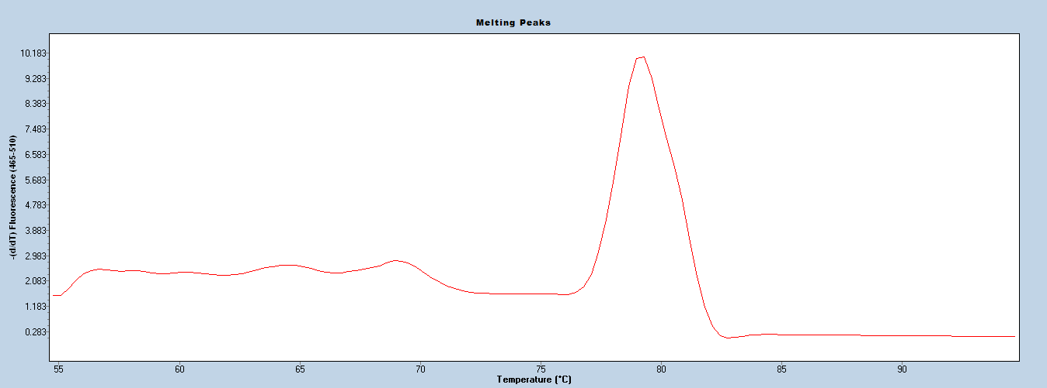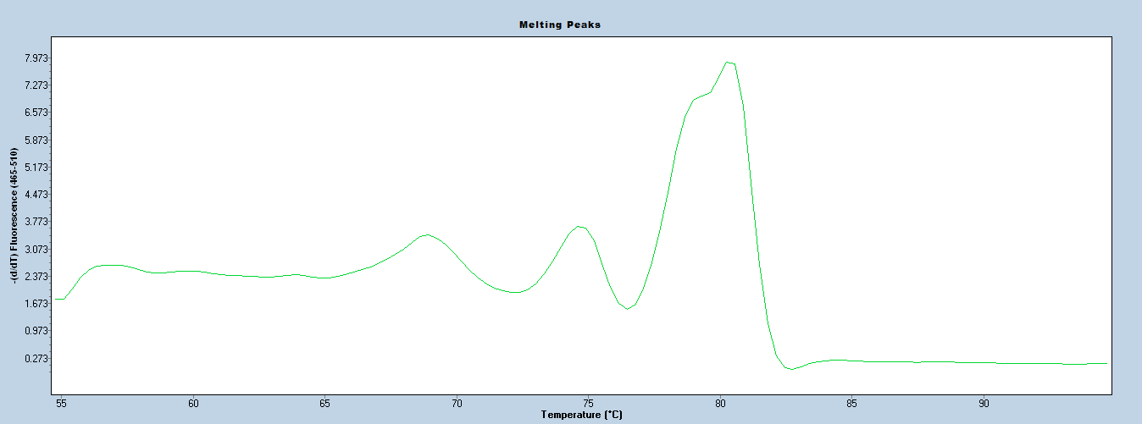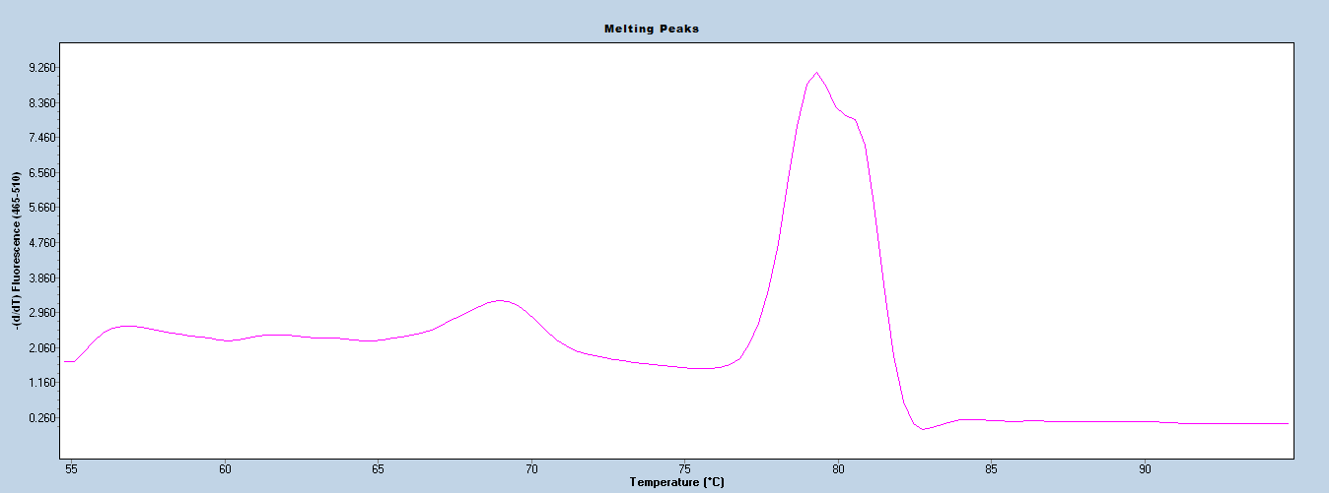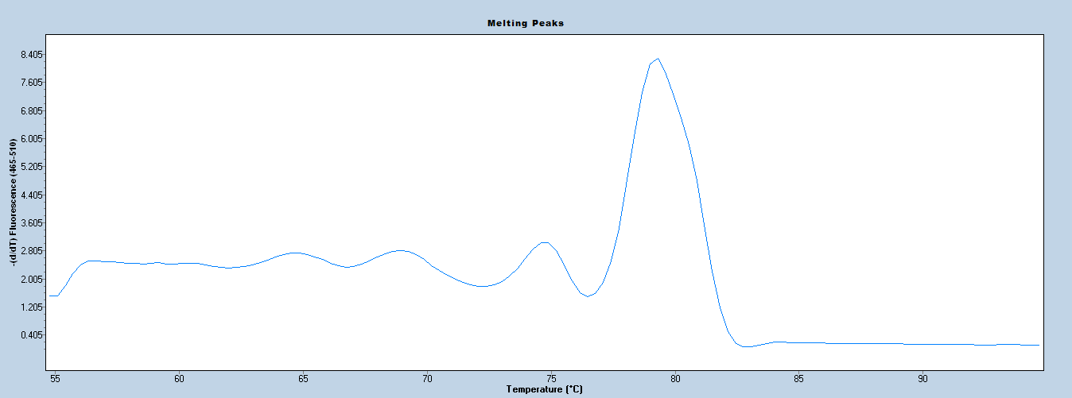

**Pc2 res. (H2)**

**Ca1 res.**

**Pc2 sus. (h2)**

**Ca1 sus.**

**Pc2 sus. (h2)**

**Ca1 res.**

**Pc2 res. (H2)**

**Ca1 sus.**

**-(d/dT) Fluorescence (465-510)**

**A**

**B**

**C**

**D**

**FaRPc2 (UFPc2H2HRM01) + FaRCa1 (UFCa1HRM02) Figure 2.** Melting curves profiles derived by the HRM analysis using multiplex of UFPc2H2HRM01 and UFCa1HRM02 in resistance and susceptibility accession of phytophthora crown rot and anthracnose fruit rot.

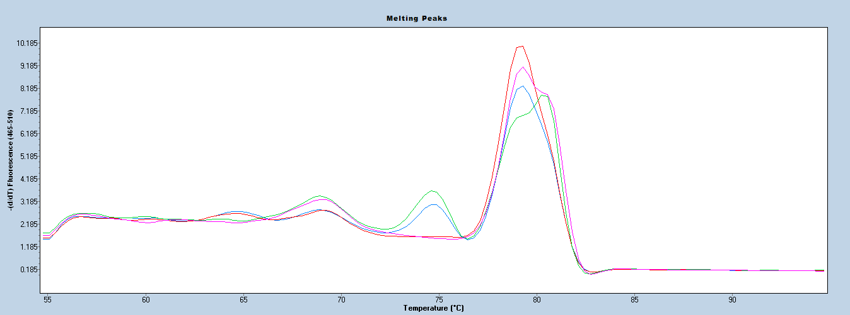

**Ca1**

***Pc2* (H2)**

**Additional Notes**

Control samples should always be used with HRM analysis to identify the melt clusters. This marker works well with crude DNA prepared by NaOH based rapid extraction.

### FaRPc2 (UFPc2H3HRM02) + FaRCa1 (UFCa1HRM02)

**Background**

* A multiplex test for Phytophthoracrown rot and Anthracnose fruit rot resistance.
* Target the *FaRPc2* H3haplotype on chromosome 7-3 and *FaRCa1* indel on chromosome 6-3 associated with resistance.
* The combination of *FaRPc2* (H3) and *FaRCa1* (Ca1) has been shown to be predictive in germplasm originating from the University of Florida breeding program.

**Technical Details**

***Primer Sequences***

|  |  |
| --- | --- |
| **Primer** | **Sequence** |
| UFPc2H3HRM02-F | TCAGAAAACCGTGGAAGCAAA |
| UFPc2H3HRM02 -R | GAACTTGACACCGGAGCATCT |
| UFCa1HRM02_F | TGTTCTGCGAGCCCTCT |
| UFCa1HRM02_R | GTCTGGGTTCTCTAAAAGGAGAGT |

***Reaction Master Mix***

|  |  |  |
| --- | --- | --- |
| **Component** | **Concentration** | **Amount for 1 reaction (μL)** |
| AccuStartTM II PCR ToughMix®a | 2X | 2.5 |
| UFPc2H3HRM02-F | 5 uM | 0.5 |
| UFPc2H3HRM02 -R | 5 uM | 0.5 |
| UFCa1HRM02_F | 5 uM | 0.15 |
| UFCa1HRM02_R | 5 uM | 0.15 |
| LCGreen® Plusb |  | 0.25 |
| Sterile PCR water |  | 0.95 |
| DNA | 50 ng/μL | 0.5 |
| **Total** |  | 5.5 |

aQuantabio (catalog number: 95142-100, 95142-800, or 95142-04K)

bBioFire Defense (catalog number: BCHM-ASY-0005 or BCHM-ASY-0006)

***PCR Program***

|  |  |  |  |
| --- | --- | --- | --- |
| **Temperature (°C)** | **Time (mm:ss)** | **Cycles** | **Process** |
| 95 | 3:00 |  |  |
| 95 | 0:15 |  | PCR |
| 60 | 0:15 | 45 |  |
| 72 | 0:15 |  |  |
| 95 | 1:00 |  | HRM |
| 55 | 1:00 |  |  |
| 95 | Continuous |  |  |
| 40 | 0:30 |  |  |
| 4 | Hold |  |  |

The PCR and HRM analysis were performed in a LightCycler® 480 (Roche Life Science).

**Interpretation**

|  |  |  |
| --- | --- | --- |
| **Predicted Trait** | **Alleles** | **Examples** |
| Phytophthora crown rot resistance | Pc2 resistance  (H3) Cluster | Camarosa, Florida Beauty, Florida Elyana, Strawberry Festival |
| Phytophthora crown rot susceptibility | Pc2 susceptibility  (h3) Cluster | Florida Brilliance, Monterey, Sweet Sensation® ‘Florida 127’, Winter Dawn, Winter Star |
| Anthracnose fruit rot resistance | Ca1 resistance  Cluster | Florida Brilliance, Florida Elyana, Florida Radiance, Sweet Sensation® ‘Florida 127’, Winter Star |
| Anthracnose fruit rot susceptibility | Ca1 susceptibility  Cluster | Camarosa, Florida Beauty, Strawberry Festival |

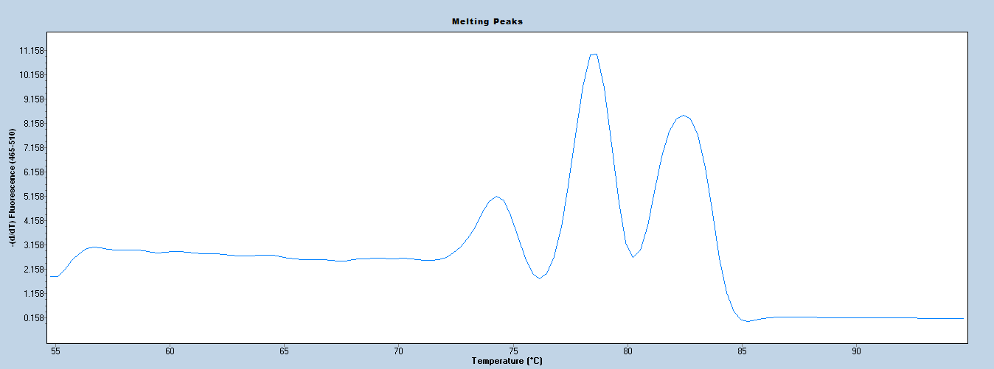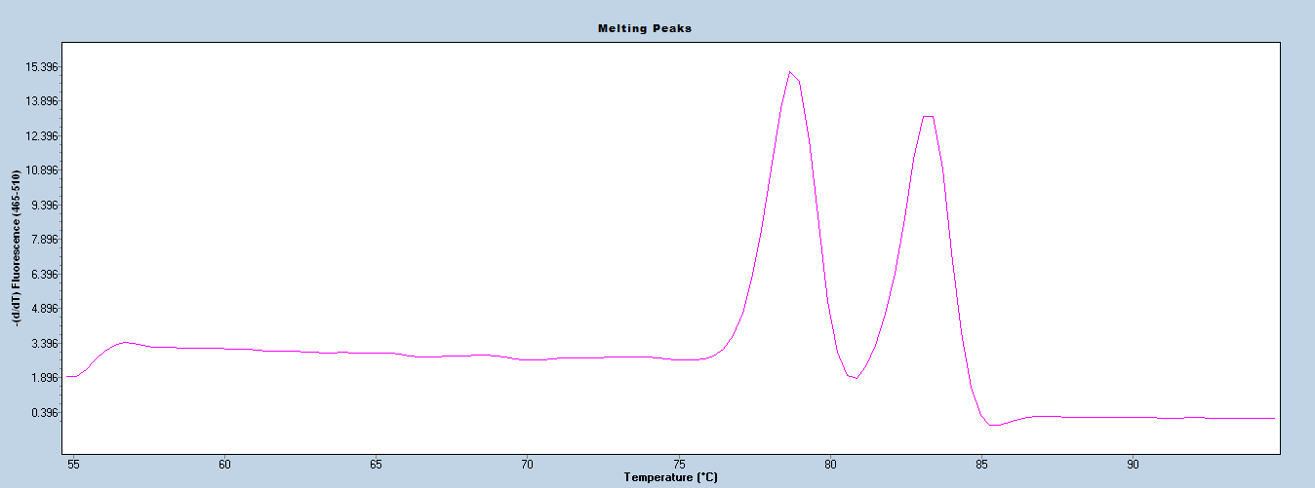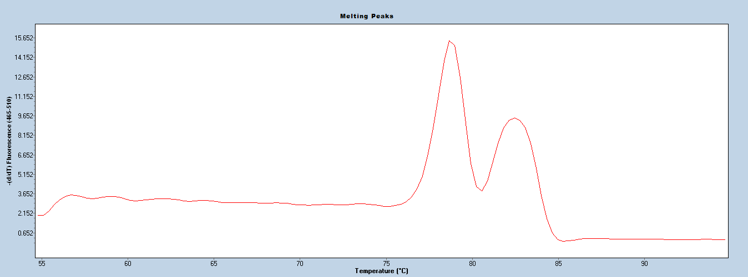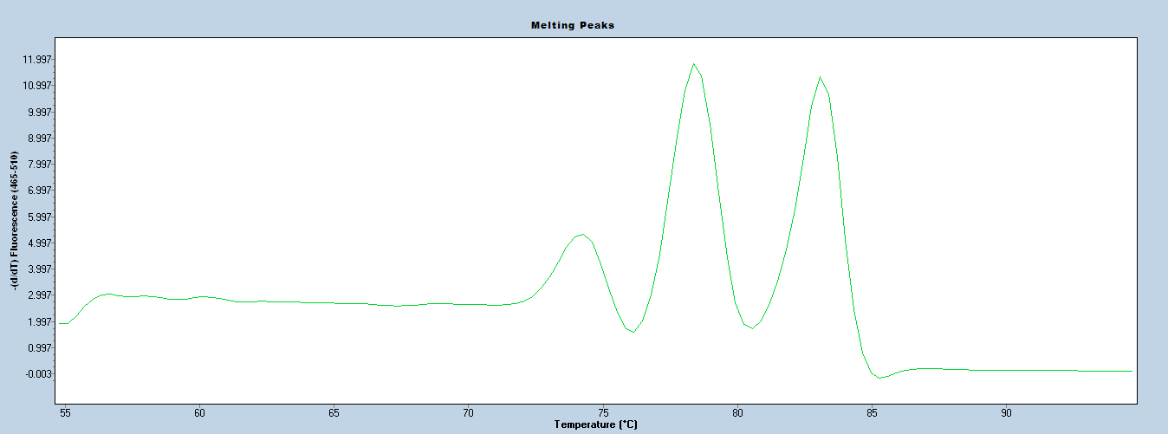

**Pc2 res. (H3)**

**Ca1 Res.**

**Pc2 sus. (h3)**

**Ca1 Sus.**

**Pc2 sus. (h3)**

**Ca1 Res.**

**Pc2 res. (H3)**

**Ca1 Sus.**

**-(d/dT) Fluorescence (465-510)**

**A**

**B**

**C**

**D**

**FaRPc2 - H3 Haplotype (UFPc2H3HRM02) + FaRCa1 (UFCa1HRM02) Figure 1.** Melting curve patterns derived by the HRM analysis using combination of two markers, UFPc2H3HRM02 and UFCa1HRM02. **A)** Phytophthora crown rot and anthracnose fruit rot resistance peak pattern; **B)** Phytophthora crown rot and anthracnose fruit rot susceptibility peak pattern; **C)** Phytophthora crown rot susceptibility and anthracnose fruit rot resistance peak pattern; **D)** Phytophthora crown rot resistance and anthracnose fruit rot susceptibility peak pattern

**FaRPc2 - H3 Haplotype (UFPc2H3HRM02) + FaRCa1 (UFCa1HRM02) Figure 2.** Melting curves profiles derived by the HRM analysis using multiplex of UFPc2H3HRM02 and UFCa1HRM02 in resistance and susceptibility accession of phytophthora crown rot and anthracnose fruit rot.

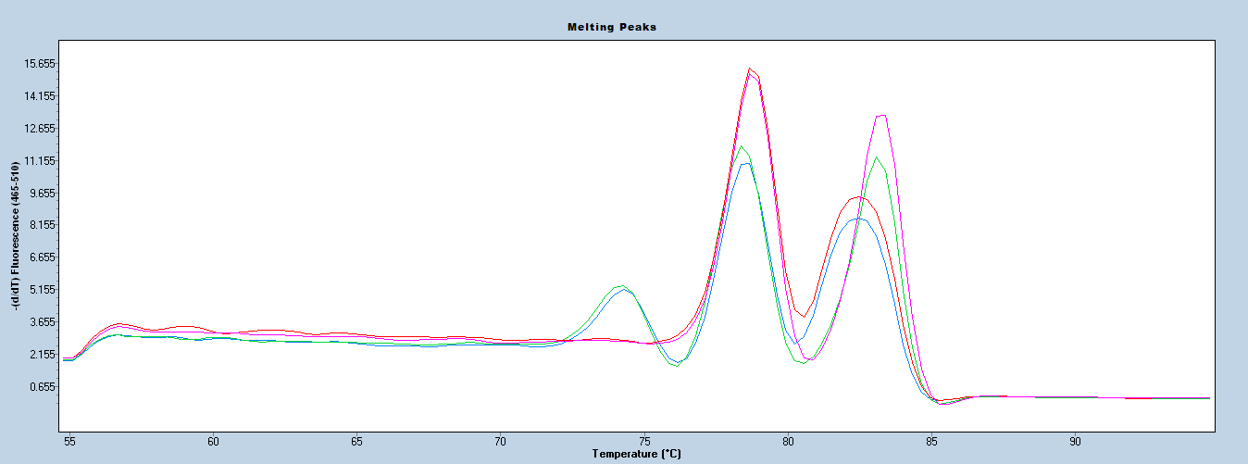

**Pc2 (H3)**

**Ca1**

**Additional Notes**

Control samples should always be used with HRM analysis to identify the melt clusters. This marker works well with crude DNA prepared by NaOH based rapid extraction.

### FaFAD1 (UFGDHRM5) + FaRPc2 (RPCHRM3)

**Background**

* A test for *Phytophthora cactorum* crown rot resistance and γ-decalactone using multiplex.
* Targets only one of two haplotypes (the *FaRPc2* H3haplotype on chromosome 7d) associated with resistance and *FaFAD1* on chromosome 3b associated with a severe reduction / absence of γ-decalactone.
* The markers, UFGDHRM5 and RPCHRM3 were designed by Noh et al., (2017 and 2018).
* The combination of UFGDHRM5 and RPCHRM3 has been shown to be predictive in germplasm originating from University of Florida breeding program.

**Technical Details**

***Primer Sequences***

|  |  |
| --- | --- |
| **Primer** | **Sequence** |
| UFGDHRM5-F | CCTCGATCATAGCTACACTCTTTC |
| UFGDHRM5-R | AGCCTTTGACGTGTCCTTATT |
| RPCHRM3-F | GTGAAGTGGAGAAAGTGGATCA |
| RPCHRM3-R | GAACTTGACACTGGAGCATCT |

***Reaction Master Mix***

|  |  |  |
| --- | --- | --- |
| **Component** | **Concentration** | **Amount for 1 reaction (μL)** |
| AccuStartTM II PCR ToughMix®a | 2X | 2.5 |
| UFGDHRM5-F | 5 uM | 0.25 |
| UFGDHRM5-R | 5 uM | 0.25 |
| RPCHRM3-F | 5 uM | 0.25 |
| RPCHRM3-R | 5 uM | 0.25 |
| LCGreen® Plusb |  | 0.25 |
| Sterile PCR water |  | 1.25 |
| DNA | 50 ng/μL | 0.5 |
| **Total** |  | 5.5 |

aQuantabio (catalog number: 95142-100, 95142-800, or 95142-04K)

bBioFire Defense (catalog number: BCHM-ASY-0005 or BCHM-ASY-0006)

***PCR Program***

|  |  |  |  |
| --- | --- | --- | --- |
| **Temperature (°C)** | **Time (mm:ss)** | **Cycles** | **Process** |
| 95 | 3:00 |  |  |
| 95 | 0:15 |  | PCR |
| 62 | 0:15 | 32 |  |
| 72 | 0:15 |  |  |
| 95 | 1:00 |  | HRM |
| 55 | 1:00 |  |  |
| 95 | Continuous |  |  |
| 40 | 0:30 |  |  |
| 4 | Hold |  |  |

The PCR and HRM analysis were performed in a LightCycler® 480 (Roche Life Science).

**Interpretation**

|  |  |  |
| --- | --- | --- |
| **Predicted Trait** | **Alleles** | **Examples** |
| *γ-decalactone Produced* | γ-decalactone producing Cluster  (GD) | Florida Brilliance, Florida Radiance, Sweet Sensation® ‘Florida 127’, Sweet Charlie, Winter Star |
| *γ-decalactone Not Produced* | non-amplification  (Non-GD) | Camarosa, Mara des Bois, Monterey, Treasure, Winter Dawn |
| Phytophthora Crown rot resistance | Pc2 resistance (H3) Cluster | Camarosa, Florida Beauty, Florida Elyana, Strawberry Festival |
| Phytophthora Crown rot susceptibility | Pc2 susceptibility (h3) Cluster | Florida Brilliance, Monterey, Sweet Sensation, Winter Dawn, Winter Star |

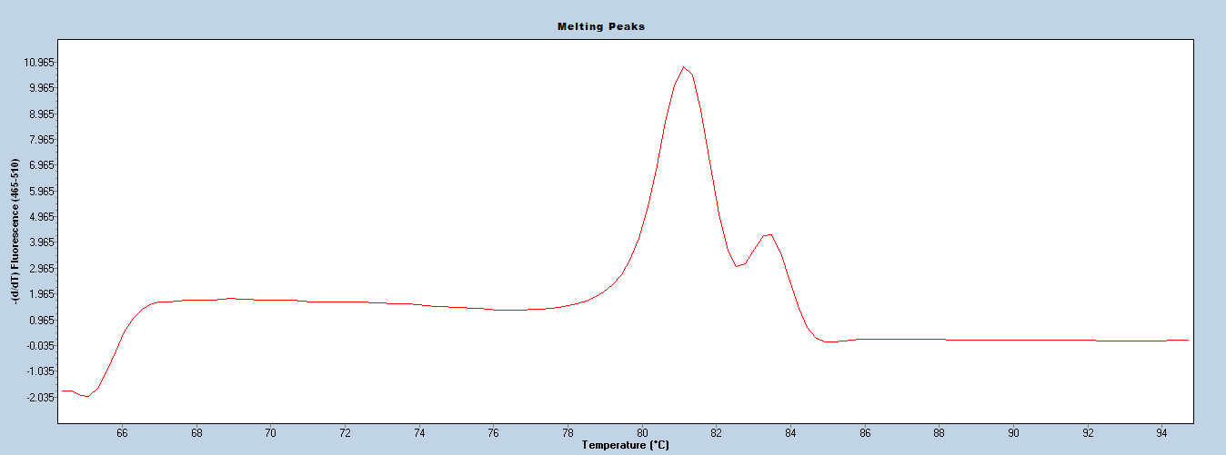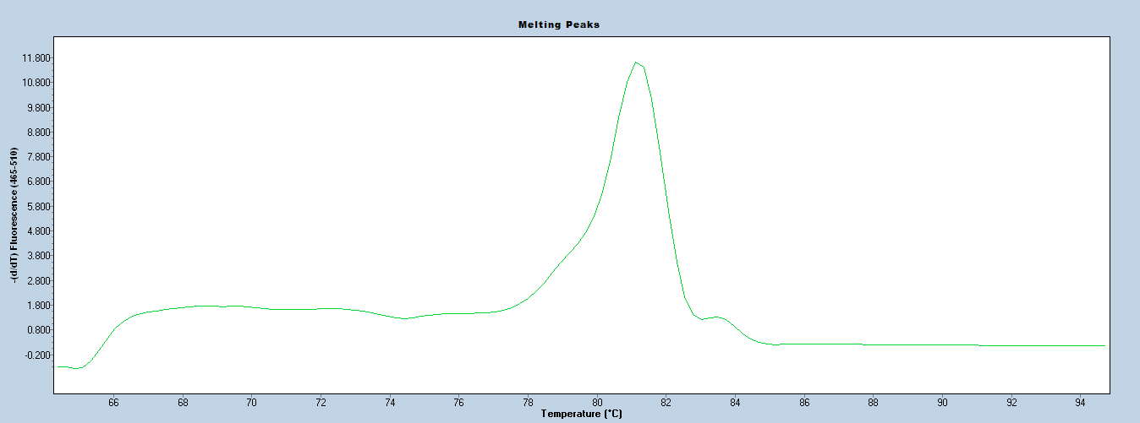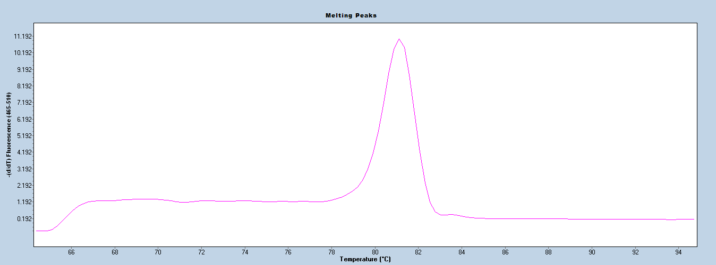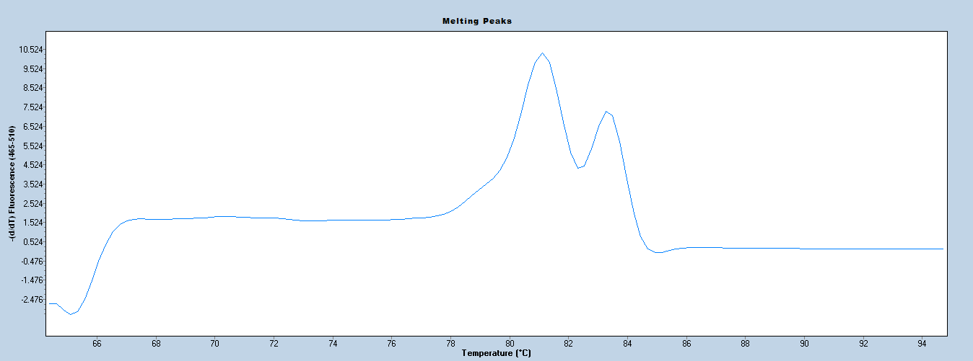

**-(d/dT) Fluorescence (465-510)**

**GD**

**Non-GD**

**Pc2 sus. (h3)**

**Non-GD**

**GD**

**Pc2 sus. (h3)**

**A**

**B**

**D**

**Pc2 res. (H3)**

**Pc2 res. (H3)**

**C**

**FaFAD1 (UFGDHRM5) + FaRPc2 - H3 (RPCHRM3) Figure 1.** Melting curve patterns derived by the HRM analysis using combination of two markers, UFGDHRM5 (GD) and RPCHRM3 (H3). **A)** Phytophthora crown rot resistance and γ-decalactone producer peak pattern; **B)** Phytophthora crown rot susceptibility and γ-decalactone non-producer peak pattern; **C)** Phytophthora crown rot resistance and γ-decalactone non-producer peak pattern; **D)** Phytophthora crown rot susceptibility and γ-decalactone producer peak pattern

**FaFAD1 (UFGDHRM5) + FaRPc2 - H3 (RPCHRM3) Figure 2.** Melting curves profiles derived by the HRM analysis using combination of two markers, UFGDHRM5 (GD) and RPCHRM3 (H3) in accession of phytophthora crown rot resistance and susceptibility and γ-decalactone producer and non-producer.

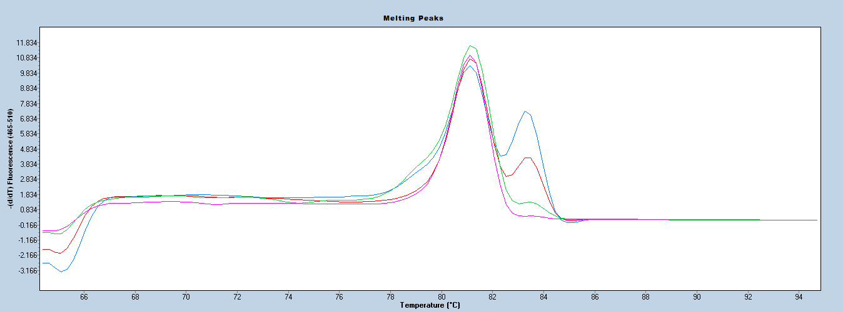

**GD**

**Pc2 H3**

**Additional Notes**

Control samples should always be used with HRM analysis to identify the melt clusters. The UFGDHRM5 is a dominant marker. As such, heterozygote cannot be identified using the current test. This marker works well with crude DNA prepared by NaOH based rapid extraction.

# **References**

Bringhurst RS, Voth V (1980) Six new strawberry varieties released. Calif Agr 34:12-15

Cruz-Rus E, Sesmero R, Ángel-Pérez J, Sánchez-Sevilla JF, Ulrich D, Amaya I (2017) Validation of a PCR test to predict the presence of flavor volatiles mesifurane and γ-decalactone in fruits of cultivated strawberry (*Fragaria* ×*ananassa*). Mol Breeding 37:131

Noh Y, Lee S, Whitaker VM, Cearley KR, Cha J-S (2017) A high-throughput marker-assisted selection system combining rapid DNA extraction and high-resolution melting and simple sequence repeat analysis: Strawberry as a model for fruit crops. J Berry Res 7:23-31

Noh Y, Oh Y, Mangandi J, Verma S, Zurn JD, Lu Y, Zhen F, Bassil N, Peres N, Cole G, Acharya C, Famula R, Knapp S, Whitaker VM, Lee S (2018) Development and validation of marker assays for high-throughput detection of Phytophthora crown rot resistance, *FaRPc2*, in the cultivated octoploid strawberry. Mol Breeding 38:104

Perrotte J, Gaston A, Potier A, Petit A, Rothan C, Denoyes B (2016) Narrowing down the single homeologous *FaPFRU* locus controlling flowering and fruit production in the cultivated octoploid strawberry using a selective mapping strategy. Plant Biotech J 14:2176-2189

Roach J.A., Verma, S, Peres NA, JamiesonAR, van de Weg WE, Bink MC, Bassil NV, Lee S, Whitaker VM (2016) *FaRXf1*: a locus conferring resistance to angular leaf spot caused by *Xanthomonas fragariae* in octoploid strawberry. Theor Appl Genet 129:1191-1201

Salinas NR, Zurn JD, Mathey M, Mookerjee S, Denoyes B, Perrotte J, Potier A, Finn CE, Hancock JF, Stewart P, Bassil NV (2017) Validation of molecular markers associated with perpetual flowering in octoploid Fragaria germplasm. Mol Breeding 37:70

Salinas N, Verma S, Peres N, Whitaker VM (2018) *FaRCa1*: a major subgenome-specific locus conferring resistance to *Colletotrichum acutatum* in strawberry. Theor Appl Genet 1-12.

Sánchez-Sevilla JF, Cruz-Rus E, valpuesta V, Botella MA, Amaya I (2014) Deciphering gamma-decalactone biosynthesis in strawberry fruit using a combination of genetic mapping, RNA-Seq and eQTL analyses. BMC Genomics 15:218

Zorrilla-Fontanesi Y, Rambla J, Cabeza A, Medina JJ, Sánchez-Sevilla JF, Valpuesta V, Botella MA, Granell A, Amaya I (2012) Genetic analysis of strawberry fruit aroma and identification of *o-methyltransferase FaOMT* as the locus controlling natural variation in mesifurane content. Plant Physiol 159:851-870